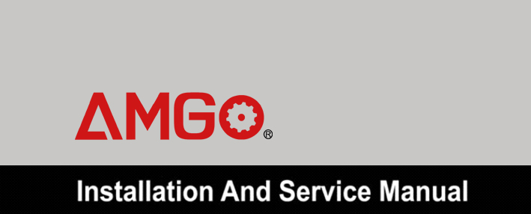

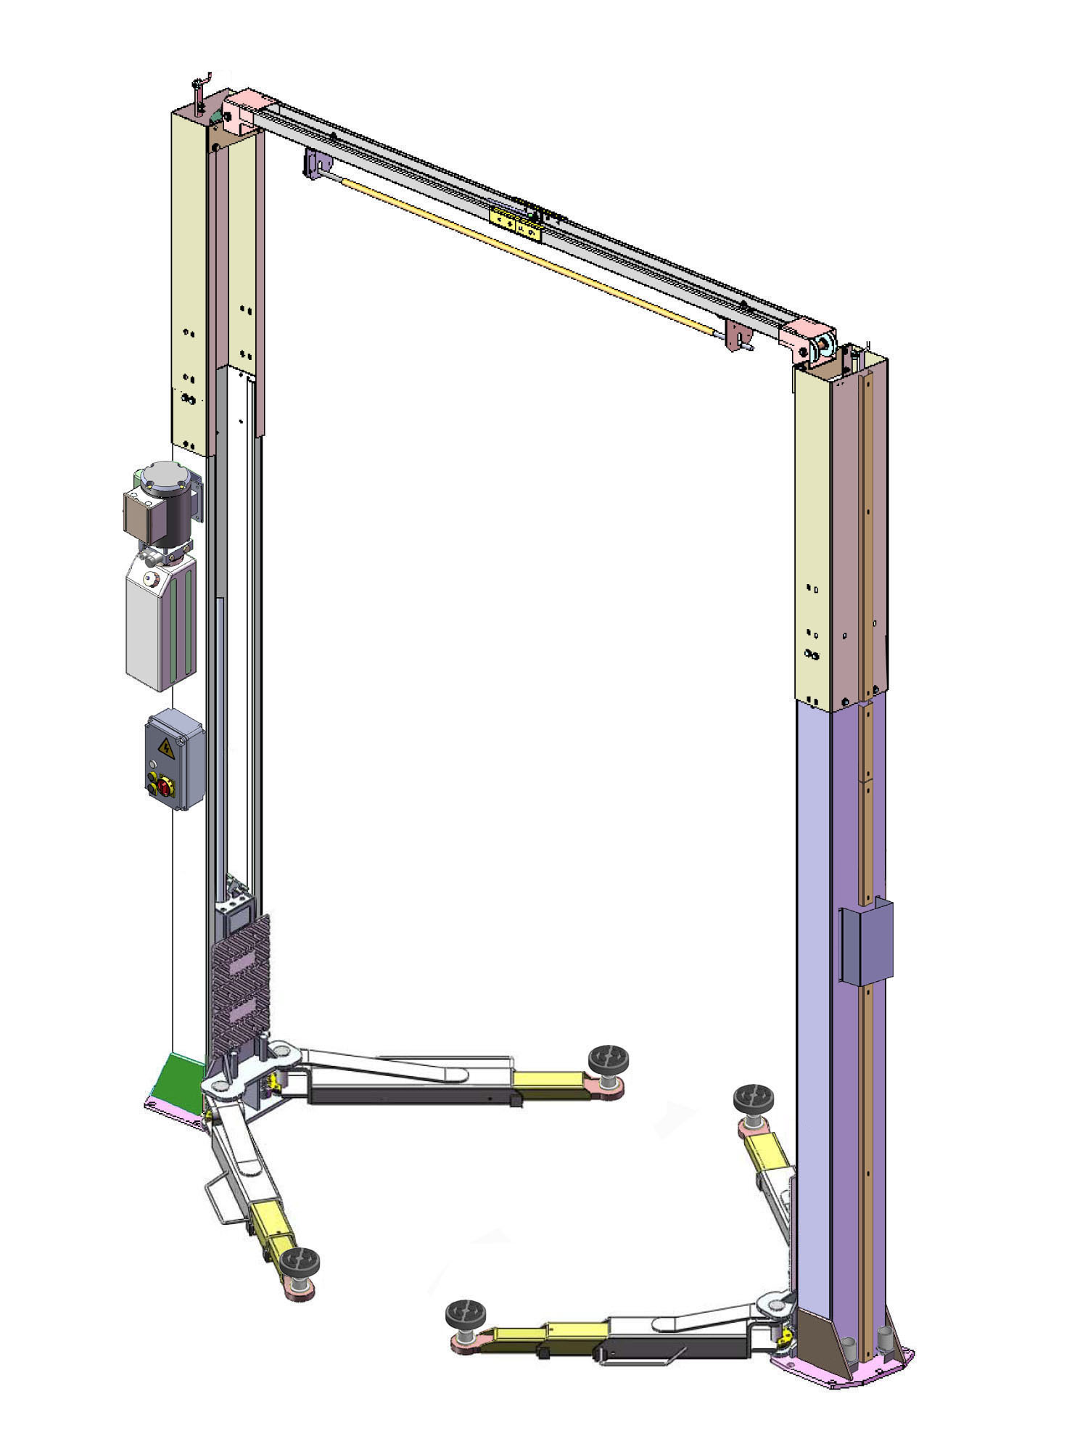

TWO-POST LIFT
Model:A240C A240CH

CONTENTS

Product Features and Specifications ............................................1

Installation Requirement ...........................................................3

Steps of Installation…………………………………………………………………………….4

Exploded View ........................................................................31

Test Run.................................................................................35

Operation Instruction ..............................................................37

Maintenance ..........................................................................37

Trouble Shooting ....................................................................38

Parts List ...............................................................................39

I. PRODUCT FEATURES AND SPECIFICATIONS
CLEAR-FLOOR DIRECT-DRIVED MODEL FEATURES
Model A240C A240CH (See Fig. 1)
· Direct-drived design, minimize the lift wear parts and breakdown ratio
· Dual hydraulic cylinders, designed and made on ANSI standards, utilizing NOK oil seal in cylinder
· Self- lubricating UHMW Polyethylene sliders and bronze bush
· Single-point safety release, and dual safety design
. Clear-floor design, provide unobstructed floor use
. Overhead safety shut-off device prevents vehicle damage
· Supersymmetric arms design, combined adapter
· Standard adjustable heights accommodates varying ceiling heights

Fig. 1
Model | Style | Lifting Capacity | Lifting Time | Lifting Height | Overall Height | Overall Width | Width  Between Columns | Minimum  Pad Height | Motor
A240C | Clear-floor  Direct-drived | 4.0T  9,000 lbs | 52S | 1825-1960mm  71 7/8” –77 1/4” | 3621/3821mm  142 1/2”/ 150 1/2” | 3428mm  135” | 2850mm  112 1/4” | 100mm  4” | 2.0/3.0 HP
A240CH | Clear-floor  Direct-drived | 4.0T  9,000 lbs | 52S | 1825-1960mm  71 7/8” –77 1/4” | 4231/4431 mm  166 1/2” /174 1/2” | 3428mm  135” | 2850mm  112 1/4” | 100mm  4” | 2.0/3.0 HP

SPECIFICATIONS

Arm Swings View
For Model A240C A240CH

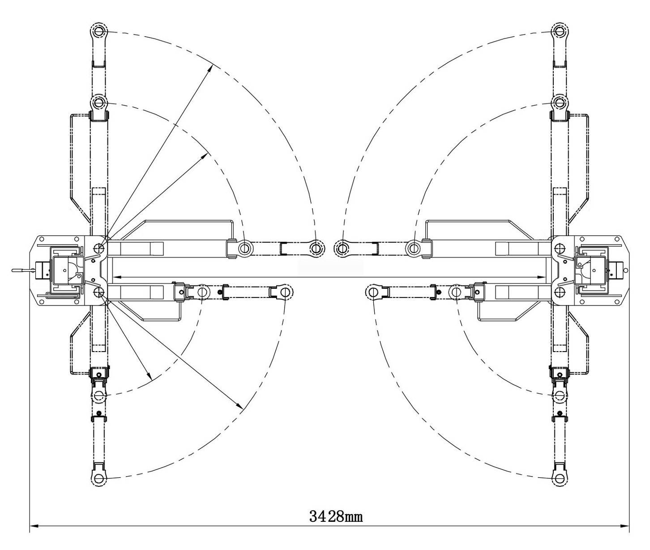

1350mm

893mm

2528mm

722mm
1285mm

Fig. 2

II. INSTALLATION REQUIREMENT
- TOOLS REQUIRED

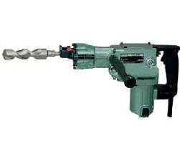
  - Rotary Hammer Drill (Φ19)

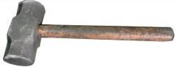
  - Hammer

  - Level Bar
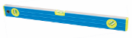

  - English Spanner (12")
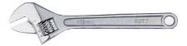

  - Ratchet Spanner With Socket (28#)
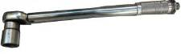

P Wrench set
  - Carpenter’s Chalk
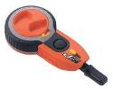

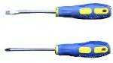
  - Screw Sets

  - Tape Measure (7.5m)
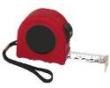

  - Pliers
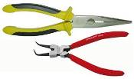

  - Socket Head Wrench (3#, 5#, 8#)
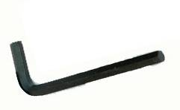

P Lock Wrench

(8#, 10#, 13#, 14#, 17#, 19#, 24#)
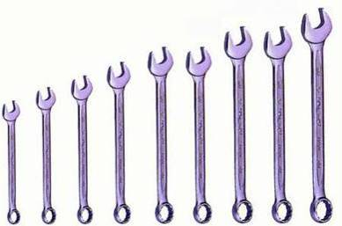

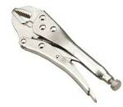

Fig. 3

Fig. 3

B. SPECIFICATIONS OF CONCRETE (See Fig. 4)
Specifications of concrete must be adhered to the specification as following.
Failure to do so may result in lift and/or vehicle falling.
1. Concrete must be thickness 100mm minimum and without reinforcing steel bars, and must be dried totally before the installation.
2. Concrete must be in good condition and must be of test strength 3,000psi minimum.
3. Floors must be level and no cracks.
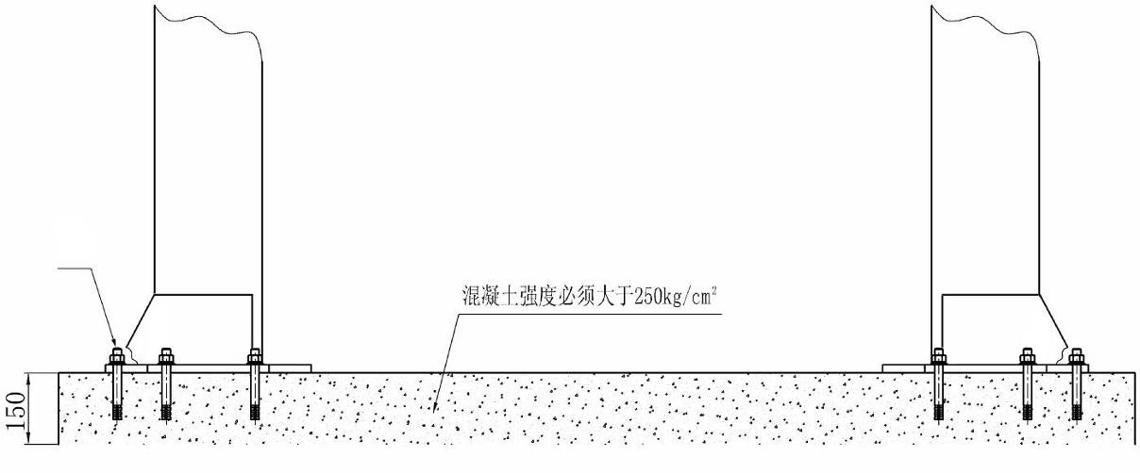
Fig. 4

81
Concrete intensity must be 3000psi minimum

100

C. POWER SUPPLY
The electrical source must be 2.2Kw minimum. The source cable size must be 2.5mm² and in good condition of contacting with floor.

III. STEPS OF INSTALLATION
A. Location of Installation
Check and insure the installation location (concrete, layout, space size etc.) is suitable for lift installation.
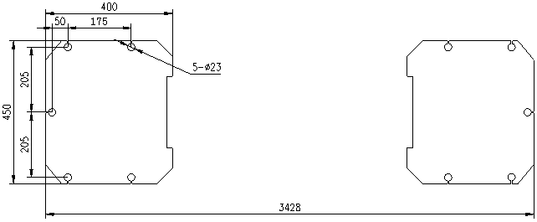
B. Use a carpenter’s chalk line to establish installation layout of baseplate (See Fig.5).
Model A240C A240CH

Chalk Line

Fig. 5

C. Check the parts before assembly.
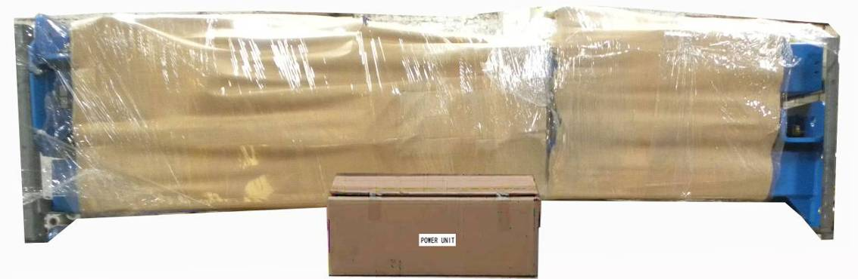
1. Packaged lift and hydraulic power unit (See Fig. 6).

Fig. 6

2. Move aside the lift with fork lift or hoist, and open the outer packing carefully
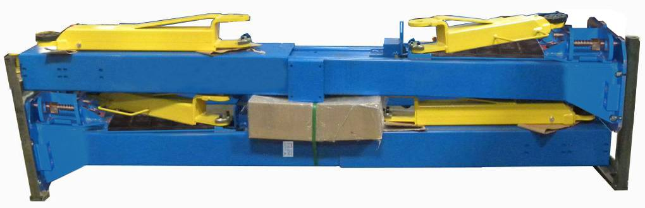
(See Fig.7).
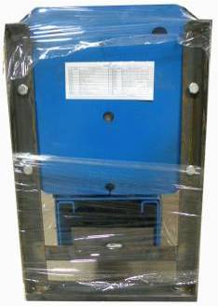

Parts box
Aluminum name plate

Extension Column
(Outer Column)

Top Connecting Assy.
Lifting Arm
Shipment Parts list

Fig.7

3. Take off the lifting arms and parts box from upper and inside the column, then move them to location nearby installation site (See Fig. 8).
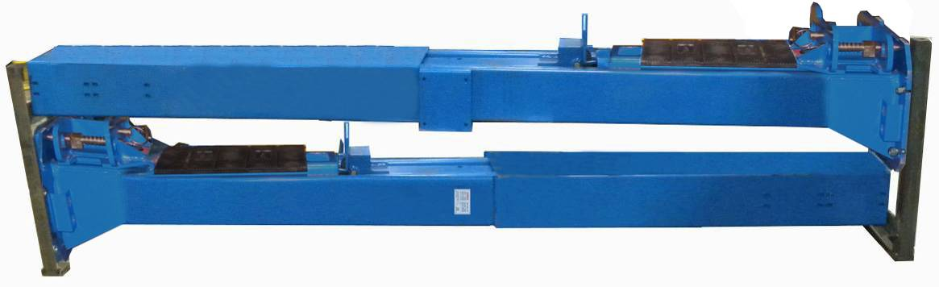

Fig.8

4. Loose the bolts of the upper package stand, take off the upper outer column, take out the parts in the inner column and remove the package stand

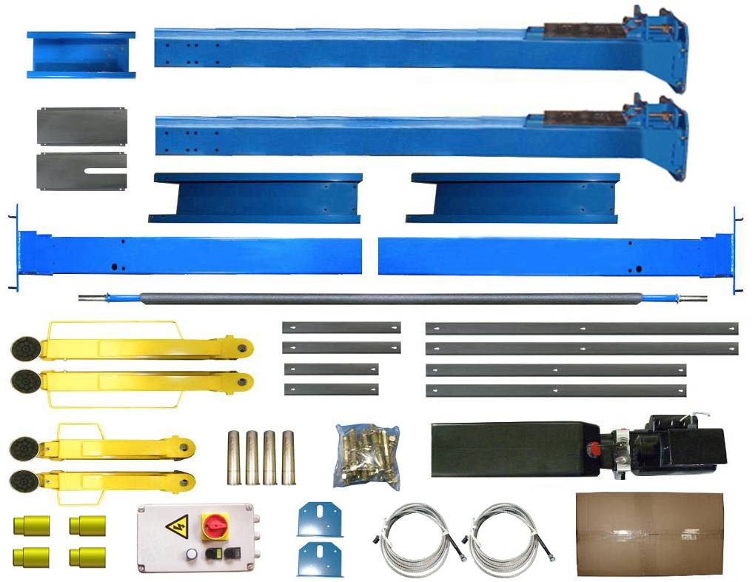
5. Move aside the parts and check the parts according to the shipment parts list, and list of parts box. (See Fig. 9, Fig. 10)
107

Fig. 9

Parts box(107)
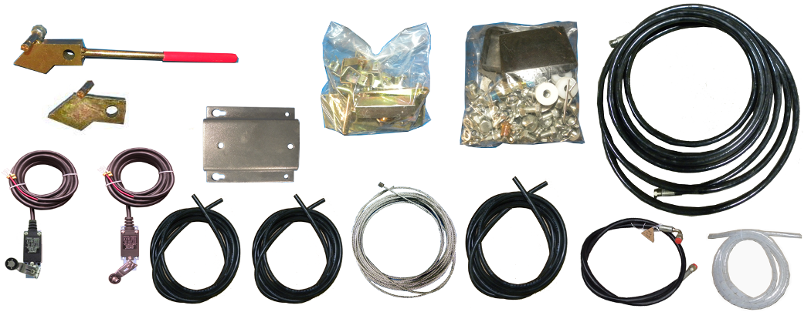

Fig.10
7. Check the parts of the parts bag 1& 2 according to parts bag list (See Fig. 11 & Fig. 12).
Model A240C A240CH
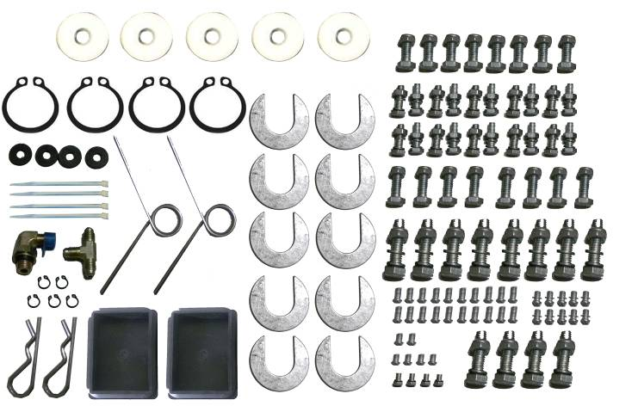
Parts bag 1
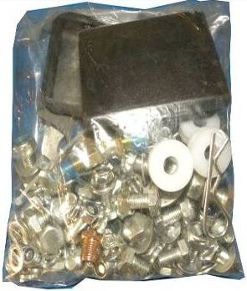

Fig. 11
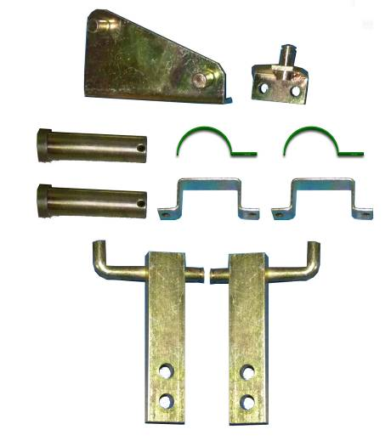
Parts bag 2

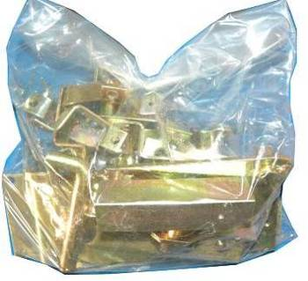

Fig. 12

D. Install parts of extension columns (See Fig. 13).
The install direction of the plastic pulley
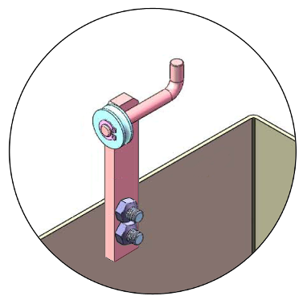

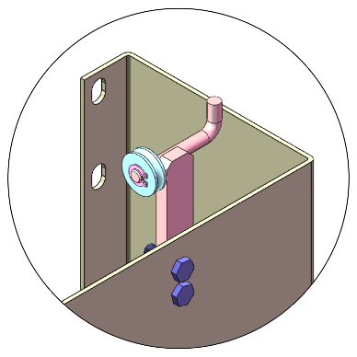

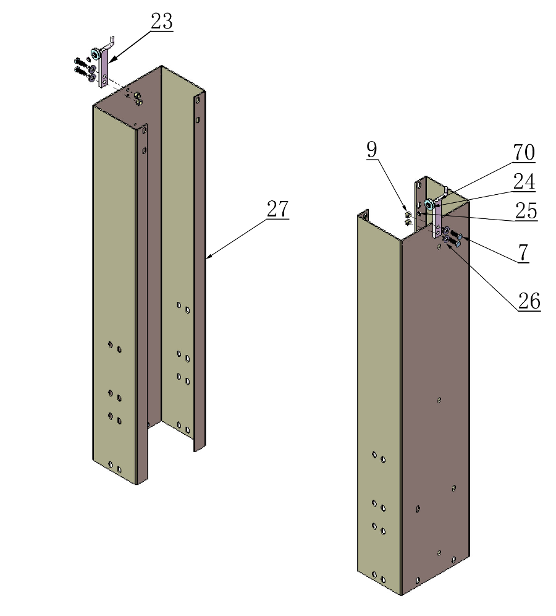

Fig. 13

E. Position powerside column
Lay down two columns on the installation site parallelly, position the powerside column according to the actual installation site. Usually, it is suggested to install powerside column on the front-right side from which vehicles are driven to the lift. This lift is designed with 2-Section columns. Adjustable height according to the ceiling height and connecting the inner and outer columns.

1. When the ceiling height is less than 3850mm (151 1/2”), connecting the outer columns with the upper hole (See Fig.14).
2. When the ceiling height is over 3850mm (151 1/2”), connecting the outer columns
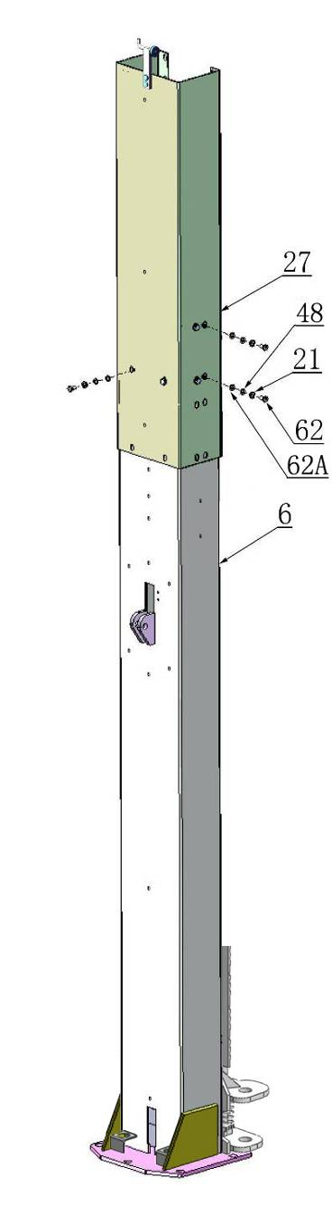
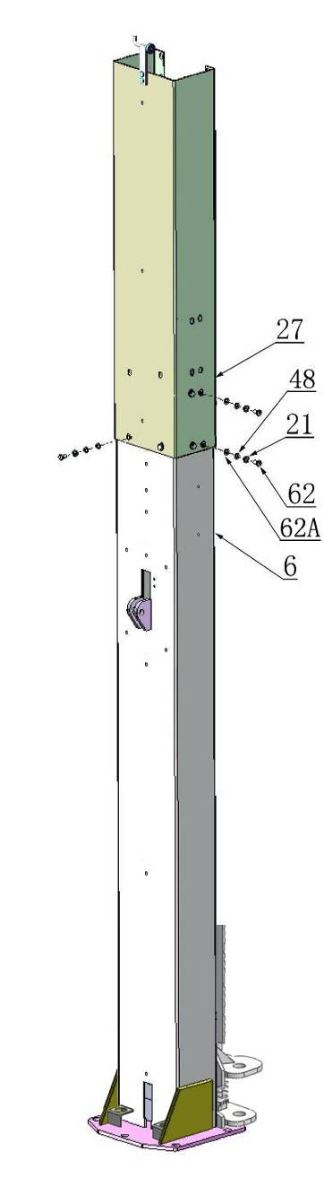
with the lower hole (See Fig.15).
44

44

Fig. 14 Low Setting
Fig. 15 High Setting

F. Position columns (See Fig. 16)
Position the columns on the installation layout of baseplate, Install the anchor bolts. Check the columns plumbness with level bar, and adjusting with the shims if the columns are not vertical. Do not tighten the Anchor Bolts.
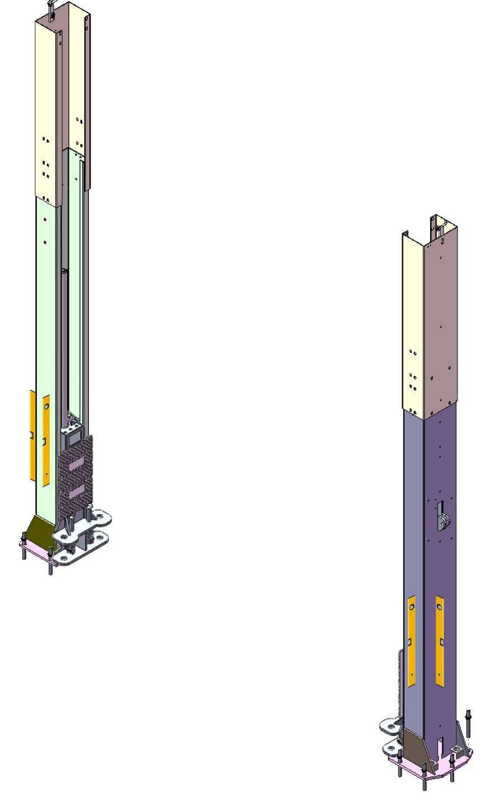

6

27

80
Width between Columns:2850mm

Check the column plumbness with lever bar from front, aside, make sure they are vertical

81

82
Overall width：3428mm

Install the anchor bolts
Note:Minimum embedment of Anchors is 90mm.

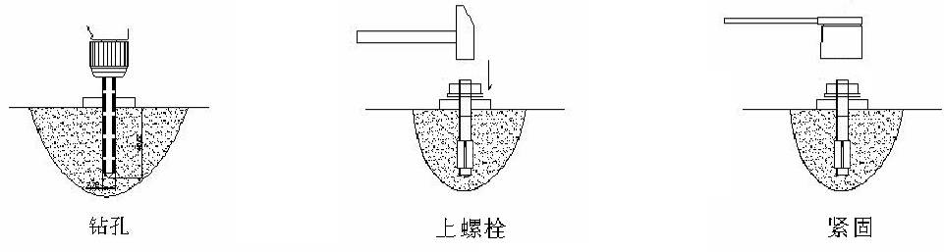
90mm

Fig. 16
Drilling
Bolting
Tighten
G. Install overhead top beam
1. With help of the hook of top beam, put one side of top beam on top of the extension column and connecting the top beam to extension column by bolts, tighten the bolts. Then assemble the connecting bracket (See Fig. 17).
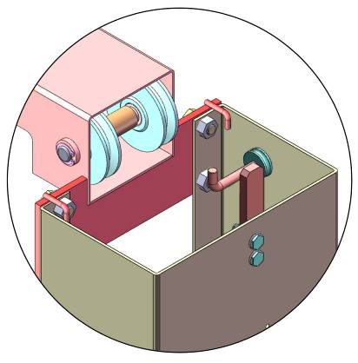
64
69
15
61
62A
62
63

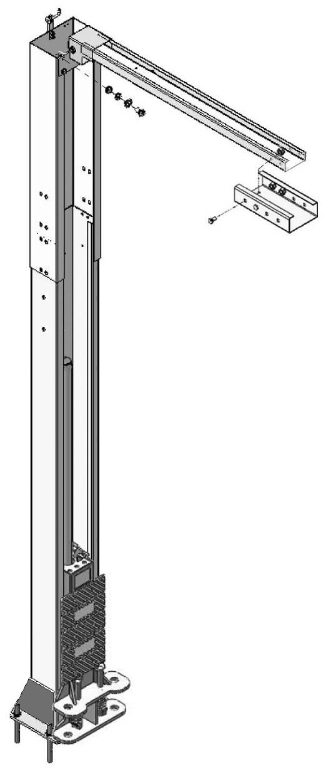

Fig. 17

2. Assemble overhead top beam, tighten the columns anchor bolts (See Fig. 18).

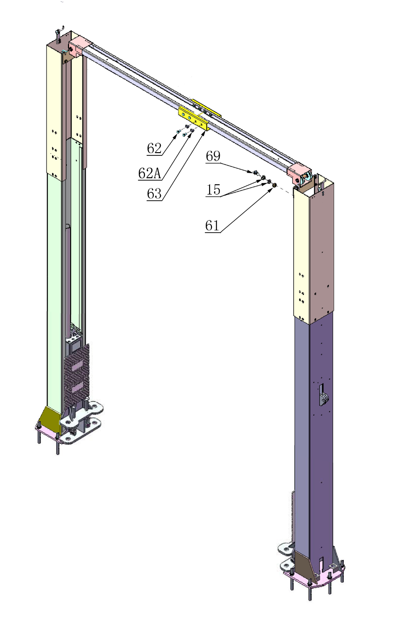

64

Tighten the anchor bolts with ratchet spanner with socket. Note: Torque of Anchors is 117N.m.
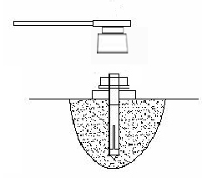

Fig. 18

H. Installing the limit switch control bar and limit switch (See Fig.19).
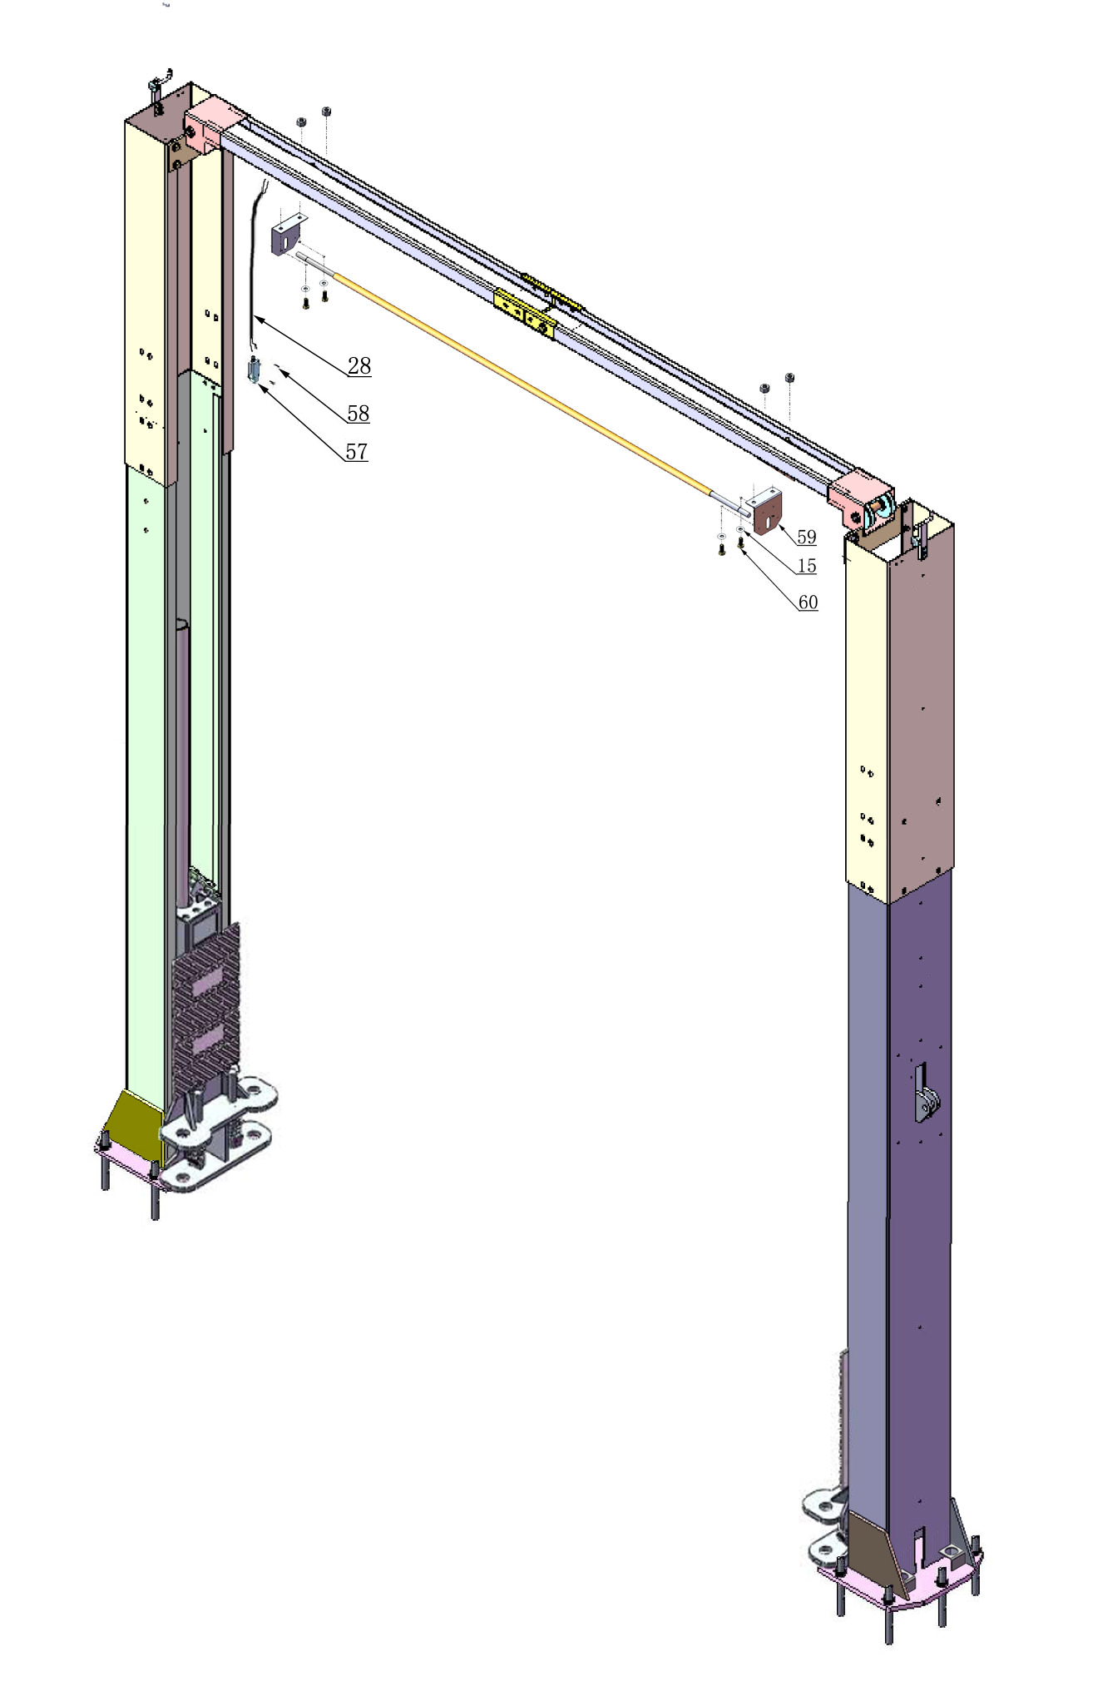
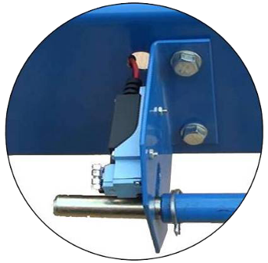
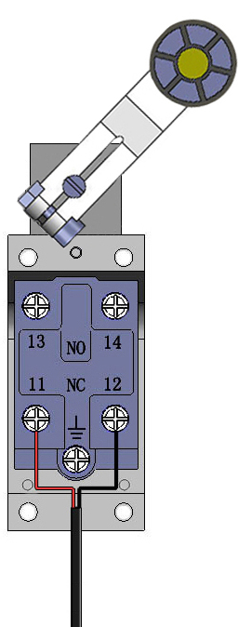
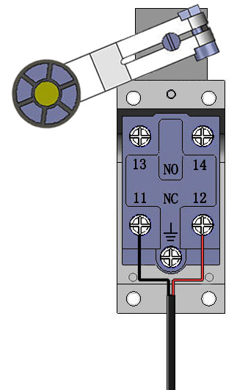
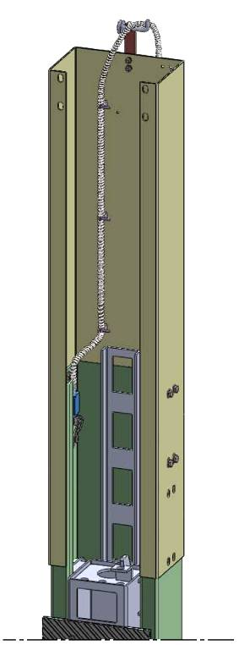
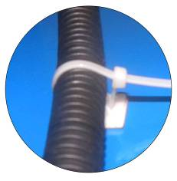
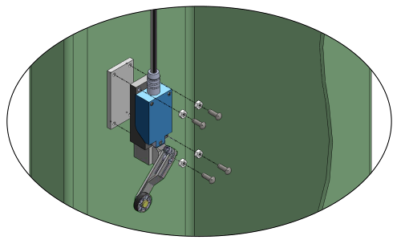
3#
2#
4#
5#
97
95
57
98
96
Control bar Limit Switch

Control bar Limit Switch

Control bar
Cylinder limit switch

30º
105
104
103
View A

61
View A


Install cylinder limit switch

30º

NC: Normal contact

Fig. 19

I. Install safety device (See Fig. 20 & Fig. 21).

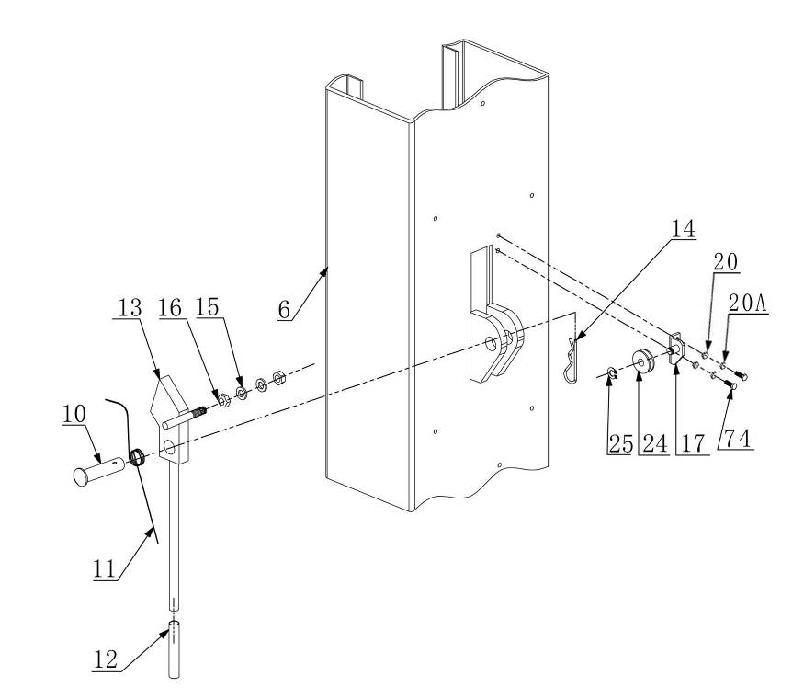
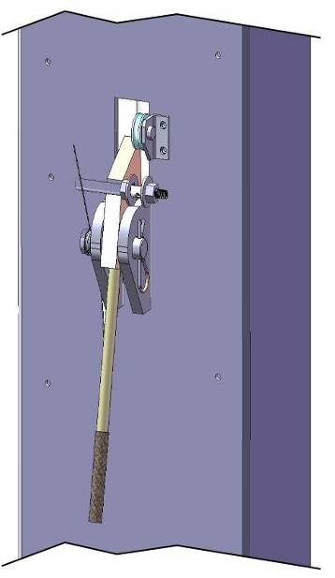

Bending here

Powerside Safety Device
Fig. 20

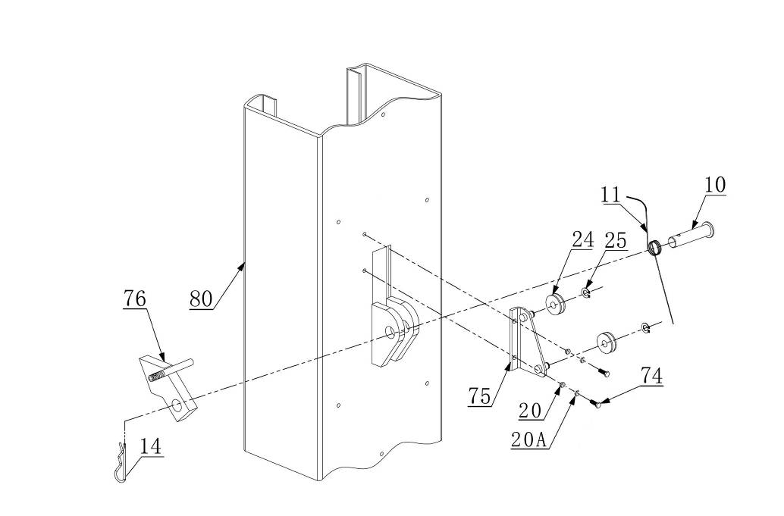
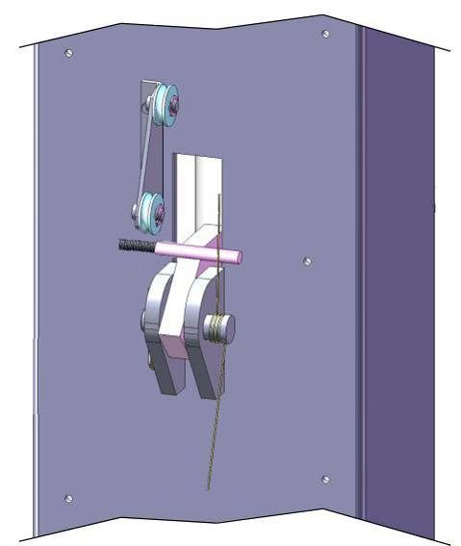

Offside Safety Device
Fig. 21

J. Lift the carriages up to about one meter high by hand and make them be locked at the same level (See Fig.22).
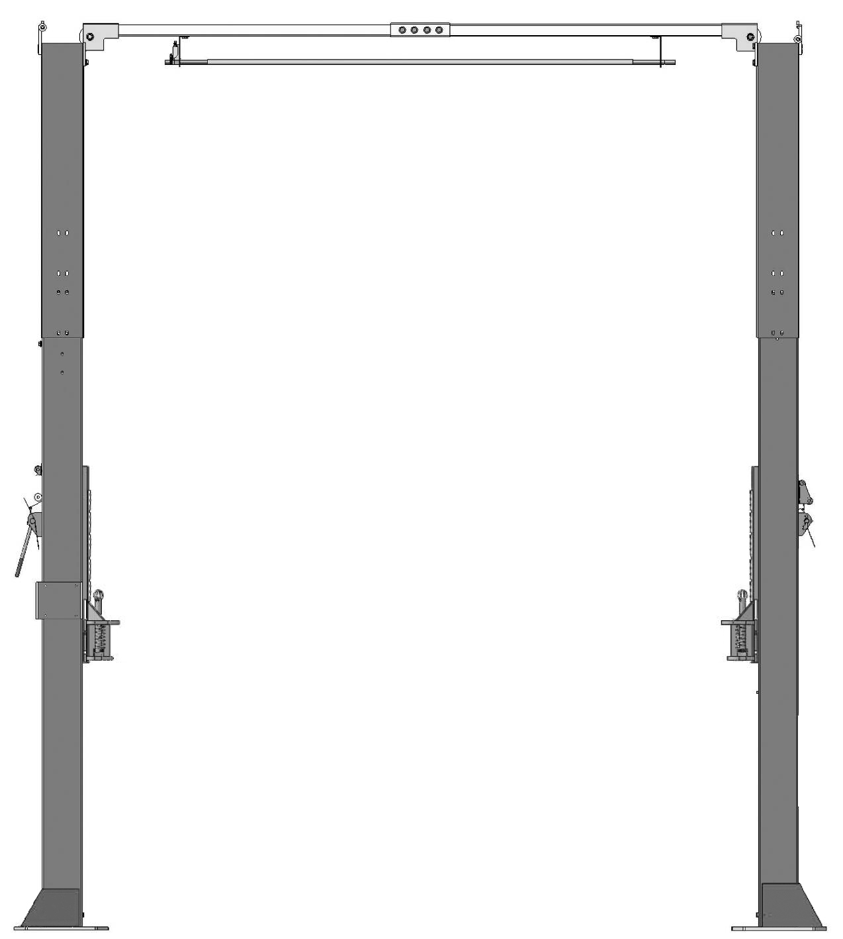
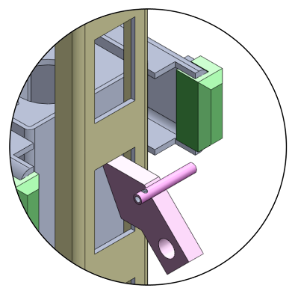
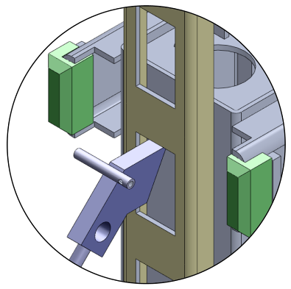
Safety block lock at the same level

Fig. 22

K. Install cables
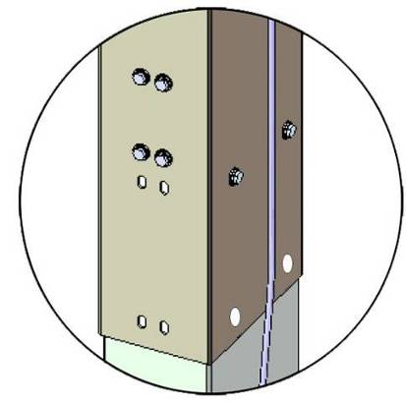
1. Low setting cable connection. Suitable for ceiling height less than 3850mm (151 1/2”) (See Fig. 23).
Low Setting

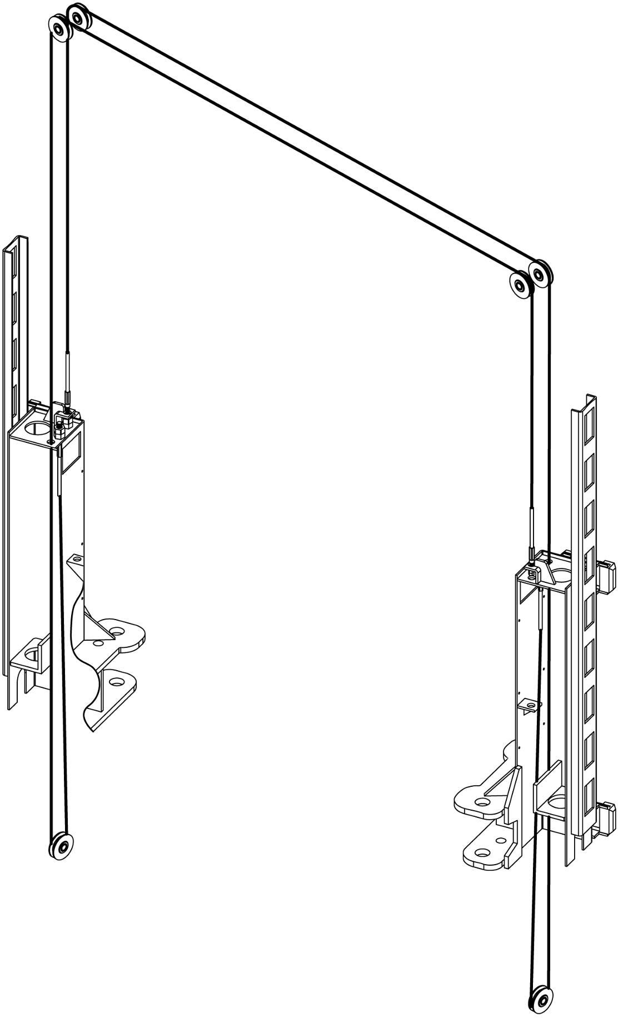

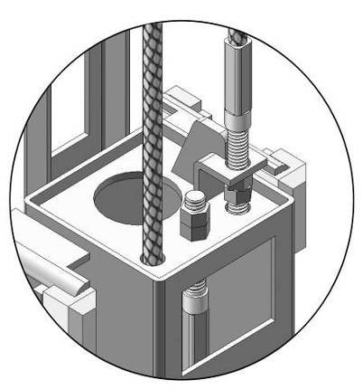
Cable 1

Cable 2

83

Cable 2

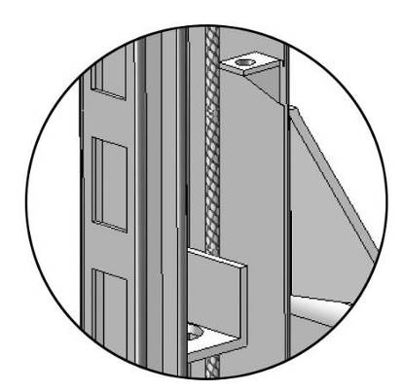

84

Fig. 23

2．High setting cable connection. Suitable for the ceiling height over 3850mm (151 1/2”) .
2.1. Cable pass through from the bottom of the carriages and be pulled out from the
open of carriages, then screw the two cable nuts (See Fig. 24).

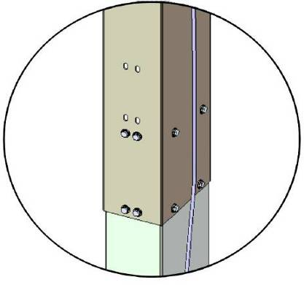
High Setting

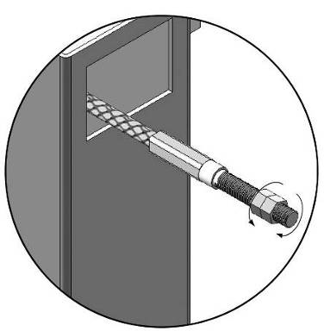
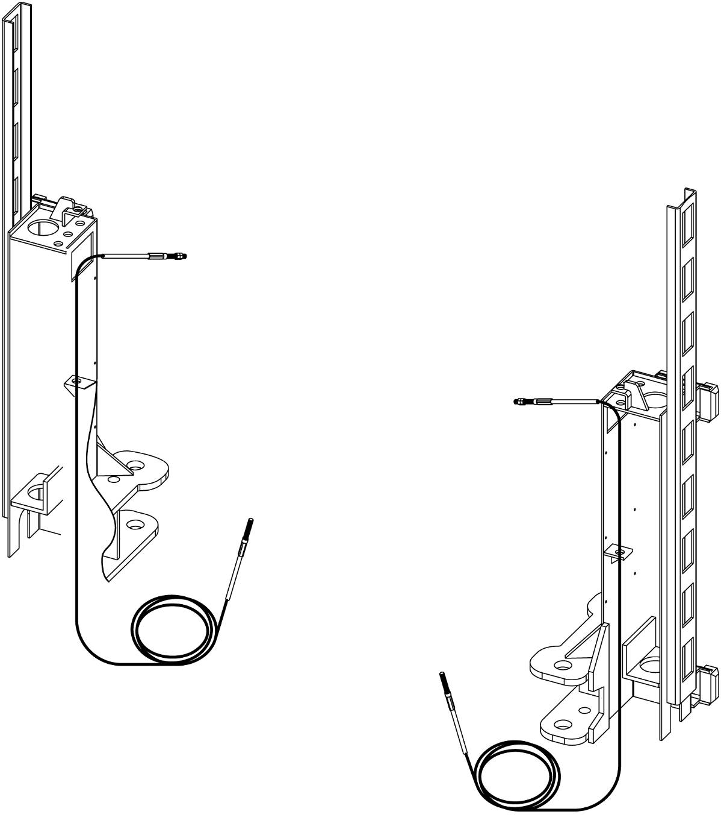

Screw the two cable nuts

Cable pass through the cable fixing plate in carriages
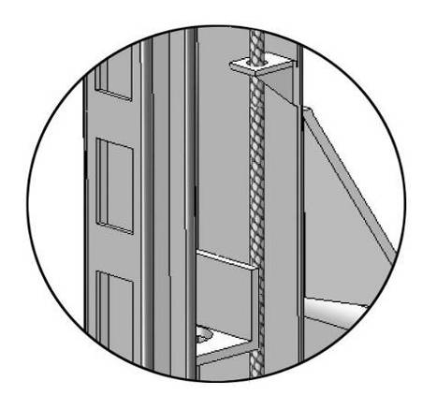

Cable Connecting direction

Cable connecting direction

Fig. 24

2.2 Connecting cable for high setting (See Fig. 25).

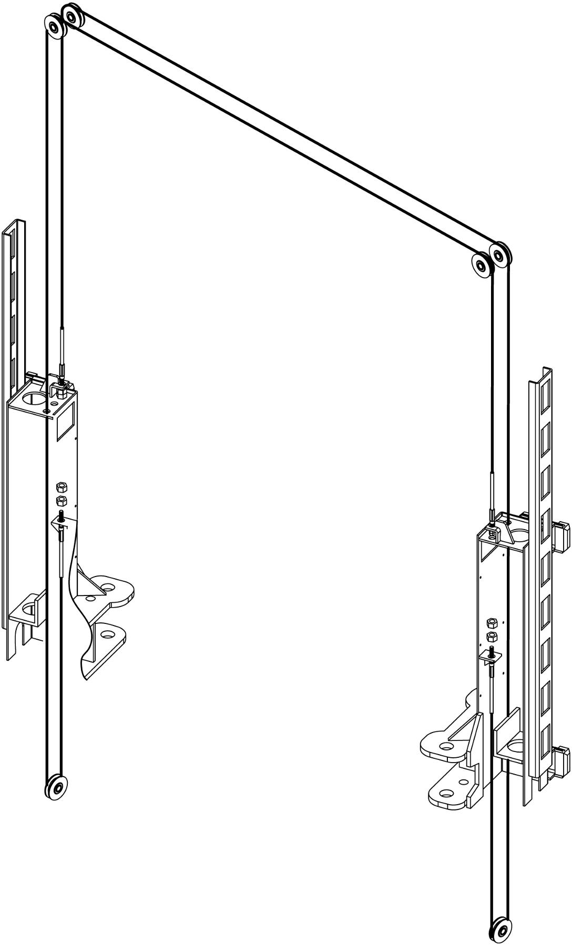

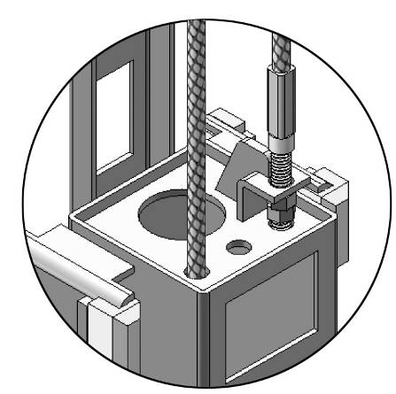
Cable 1

Cable 2

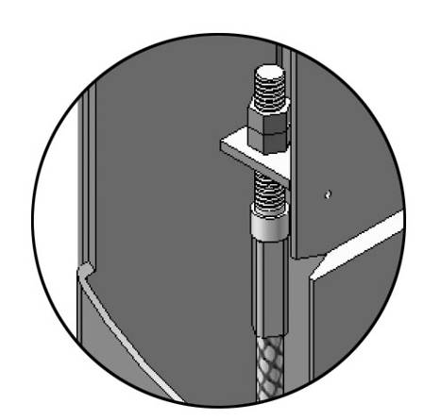
83

84

Cable 2

Fig. 25

L．Install safety cable (See Fig. 26)

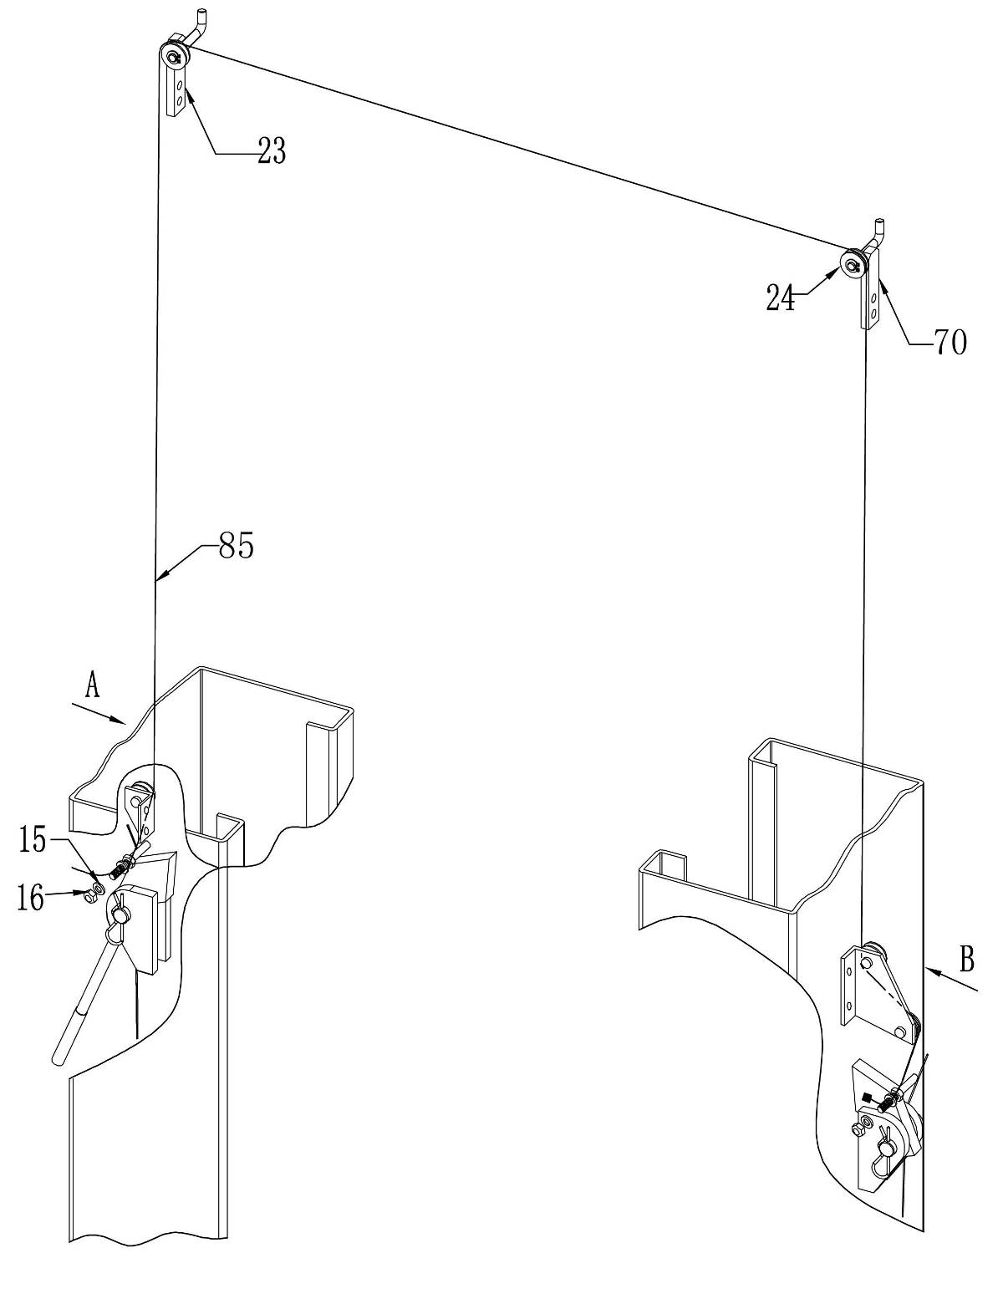
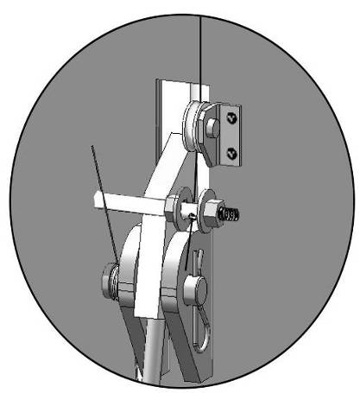
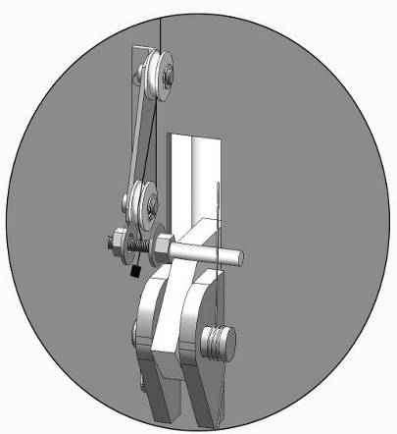

View A

Tighten the nut after finishing installation of safety cable

View B

Assemble safety cable from offside safety assy.

Fig. 26

M. Install motor bracket, hydraulic power unit and oil hose assy.(See Fig. 27)
Tighten all the hydraulic fittings, and fill the reservoir with hydraulic oil.
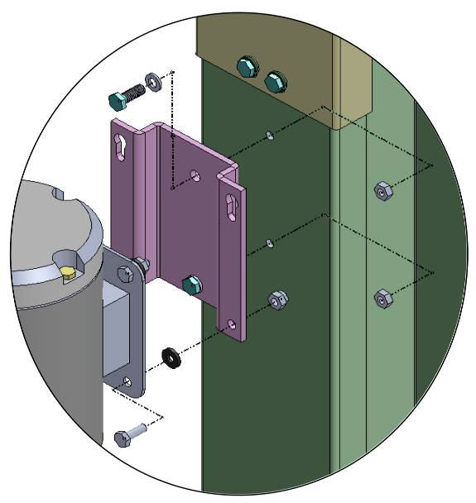
Note: In consideration of Power Unit’s durability and keep the equipment running in the perfect condition, please use Hydraulic Oil 46#
62A
86
99
21
9
200

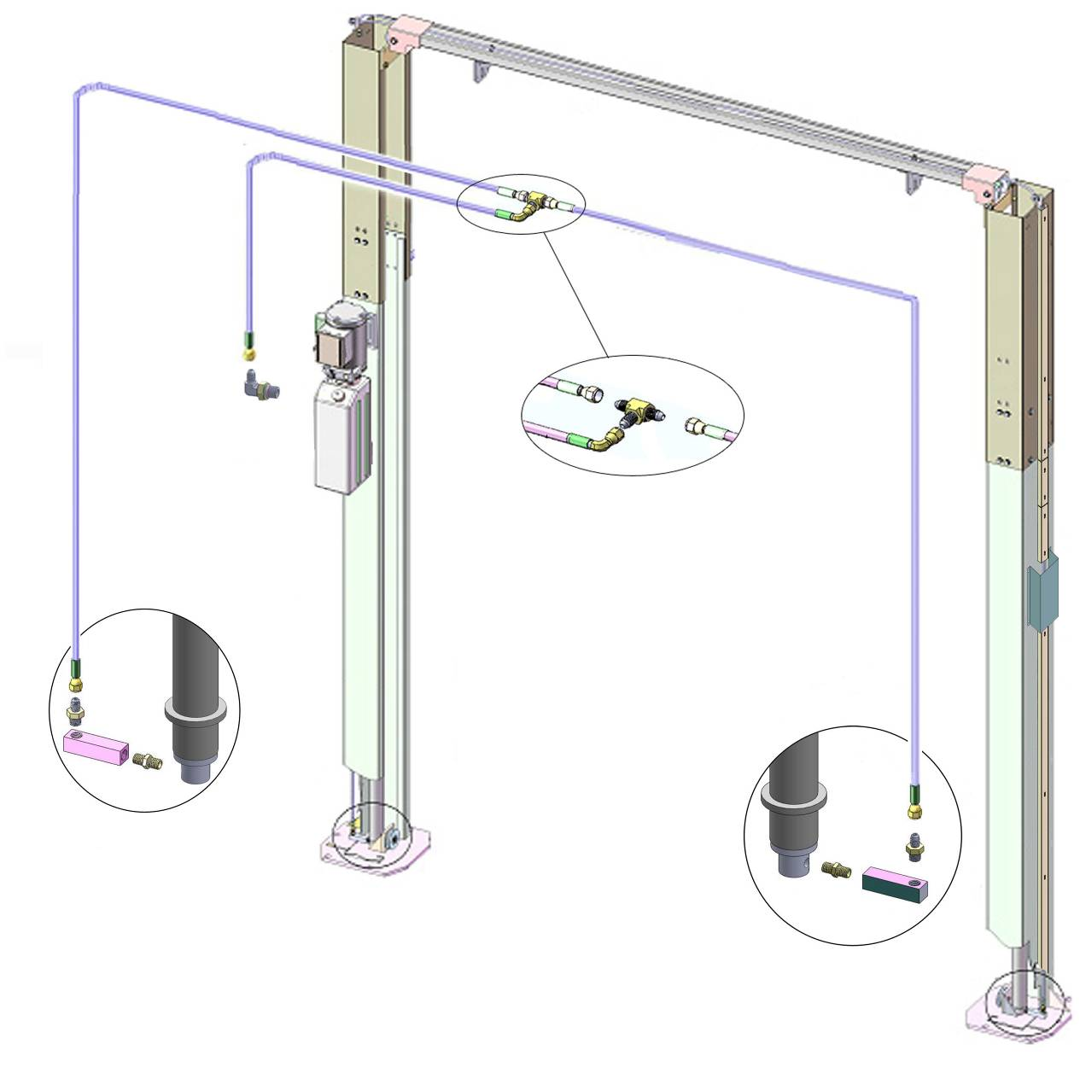
8
7

87
92
89
30
91
90
92
88
88A

Fig. 27

N. Install control box.(See Fig. 28)
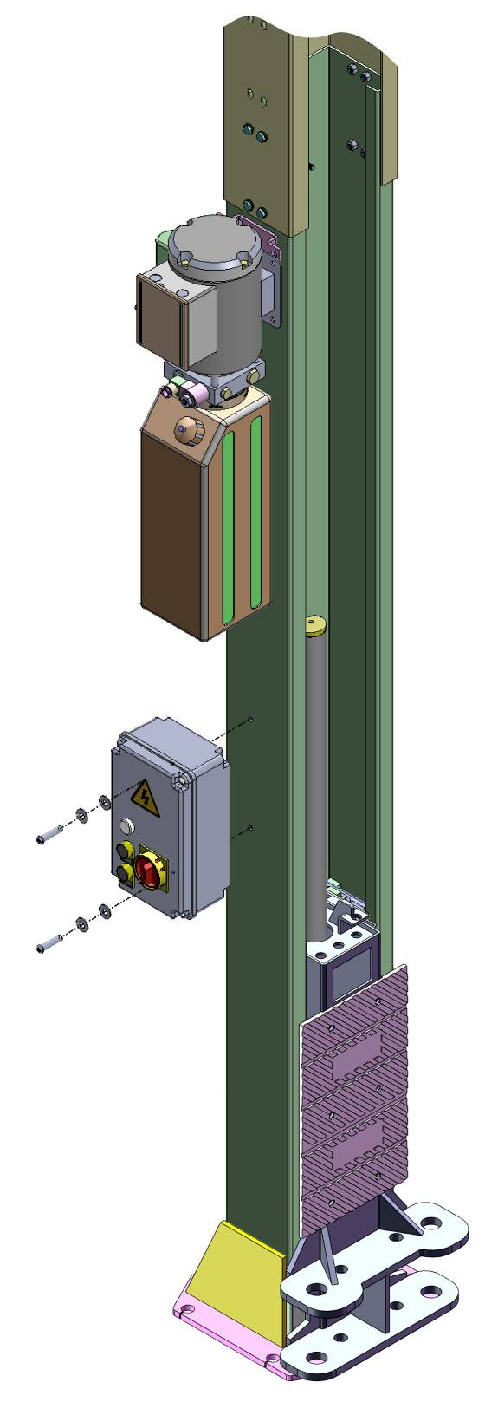
93
94
20
20A

Fig. 28

O. Install electrical system
1. Connecting wire with control box (See Fig. 29)
Note: 1) Specification of wire of limit switch and hydraulic solenoid valve is 2×1²
2) Wire cable for power source and motor are 4×2.5²
3) Using white bobbin to wind around wire
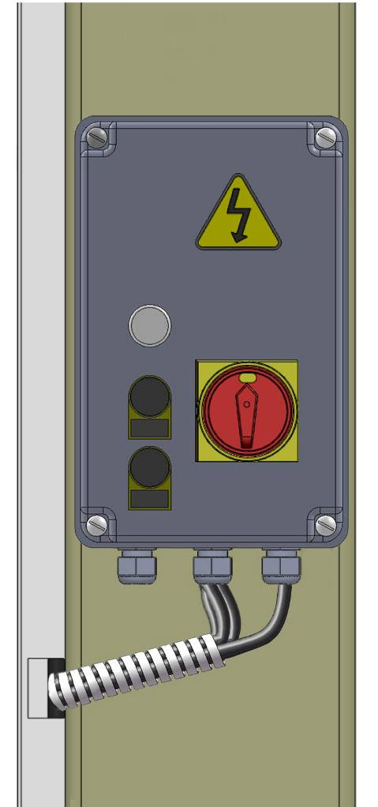
102
101
100
Connecting wire cylinder limit switch
Connecting the power wire

Connecting wire of control bar limit switch

Connecting wire of hydraulic Solenoid Valve

Connecting wire of motor

Fig. 29

2. Adjusting the current rating of thermal relay in control box according to the different configurations of hydraulic power unit. In general, the electric current of thermal relay should equal or larger than that of motor. The following table shows rated current regulation of thermal relay in case of different hydraulic power unit.

Hydraulic power unit | PEAK |  |  | SPX
Hydraulic power unit | 220V  3HP | 380V  3HP | 415V  3HP | 220V  3HP | 380V  3HP
Rated current of thermal relay | 16A | 12A | 12A | 18A | 12A

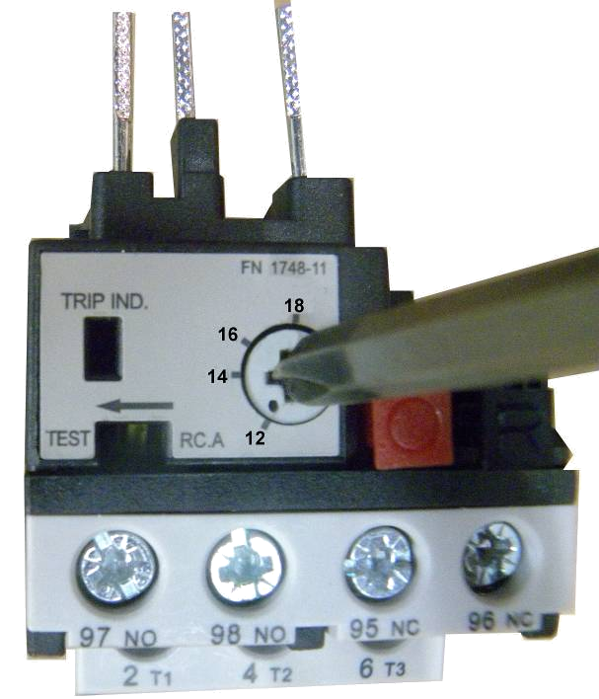
Using cross screwdriver to adjust rated current value of thermal relay

This point shows the present rated current value

Fig. 30

3. 380V Wire connection and circuit diagram
3.1 Wire connection diagram in the control box (See Fig. 31)
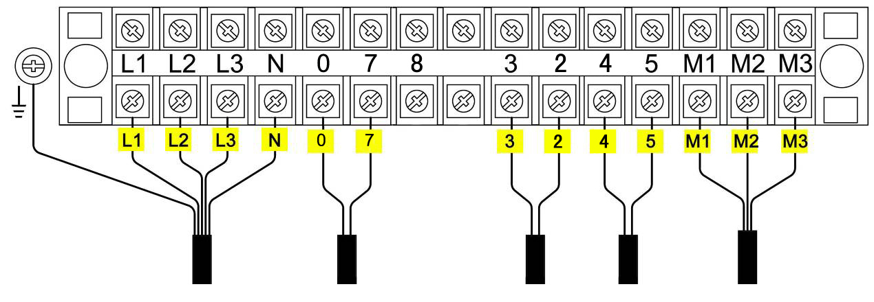
Power wire

Wire of hydraulic solenoid valve

Wire of control bar limit switch
Wire of motor

Earth wire

Wire of cylinder limit switch

Fig. 31

3.2 380V Wire connection diagram of hydraulic motor (See Fig. 32)
Motor wires (M1、M2、M3) are connected to the three wires in the motor.
Turn on the power, push UP button, if motor run but lift is not worked, please. change the wires connection.

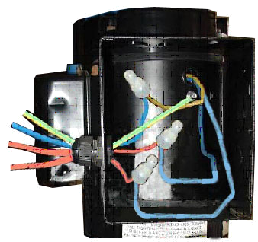
Earth wire
M3
M2
M1

Fig. 32

3.3 380V Circuit diagram (See Fig. 33)
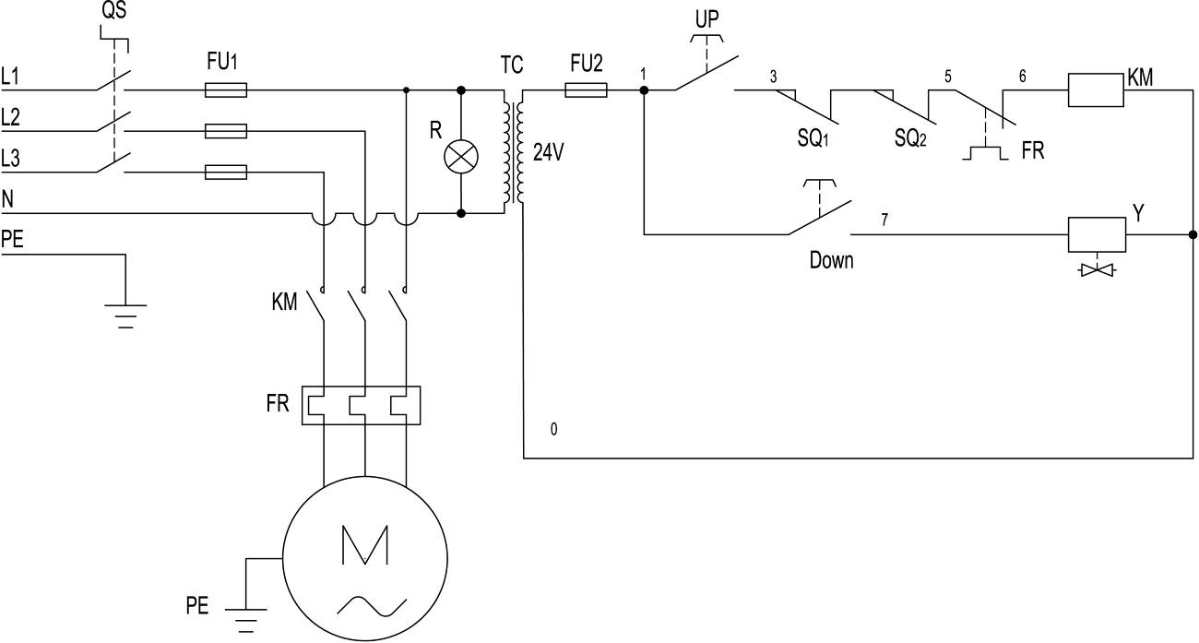

Fig. 33

3 Phases

Circuit diagram component list for 380V Power
Item | Name | Code | Specification |  | Item | Name | Code | Specification
1 | Power Switch | QS | 380V AC |  | 7 | Alarm Lamp | R | 220V (White)
2 | Fuse | FU₁ | 25A |  | 8 | Push Button | Down | Single
3 | Fuse | FU₂ | 3A |  | 9 | Motor | M | Three phases
4 | AC Contactor | KM | 24V AC |  | 10 | Transformer | TC | 24V AC
5 | Hydraulic Solenoid Valve | Y | 24V AC |  | 11 | Limit Switch | SQ | 10A
6 | Push Button | UP | Single

4. 220V Wire connection and circuit diagram
4.1 Wire Connection diagram in the control box (See Fig. 34)
Power wire

Wire of motor

Wire of cylinder limit switch

Earth wire

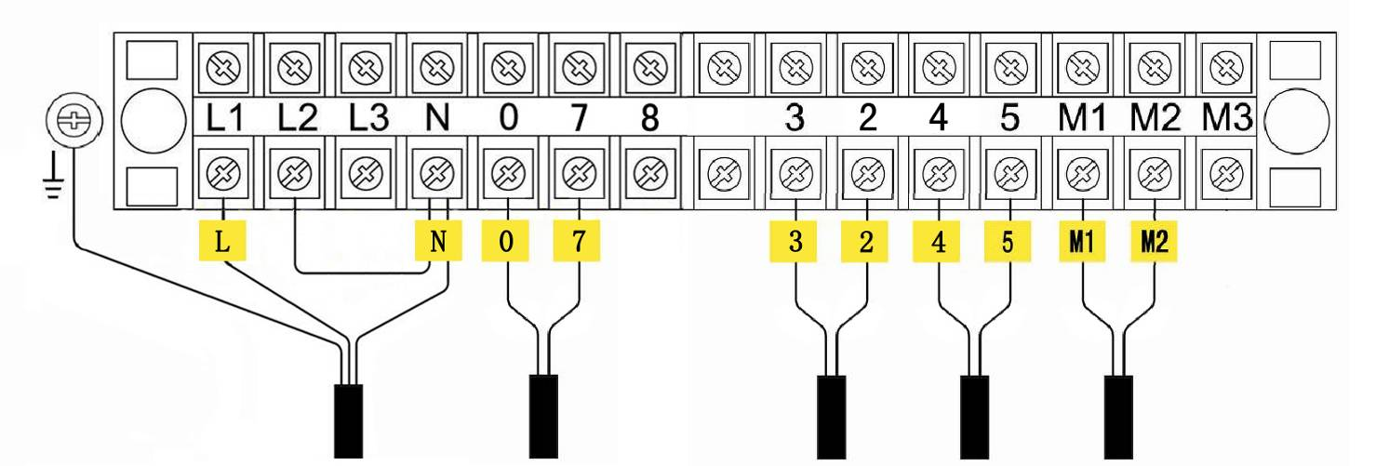

Wire of hydraulic solenoid valve

Wire of control bar limit switch

Fig. 34
4.2 220V Wire connection of hydraulic power unit (See Fig. 35).
Motor wires (M1、M2) are separately connected to two wires in the motor
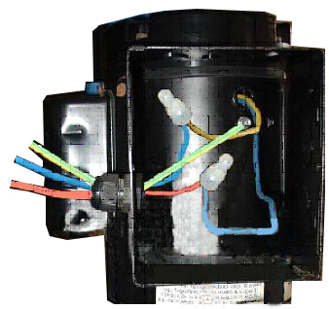

Earth wire

M2
M1

Fig. 35

  - 220V Circuit diagram (See Fig. 36).
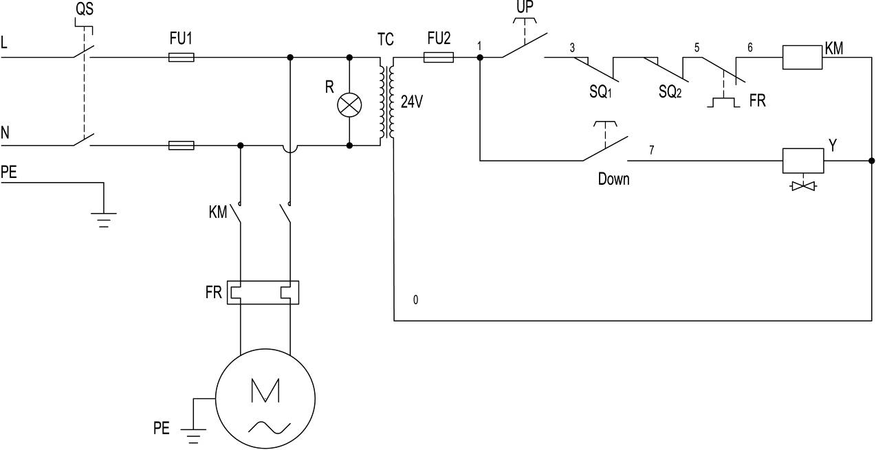
Single phase

Fig. 36

Circuit diagram component list for 220V Power
Item | Name | Code | Specification |  | Item | Name | Code | Specification
1 | Power Switch | QS | 380V AC |  | 7 | Alarm Lamp | R | 220V (White)
2 | Fuse | FU₁ | 25A |  | 8 | Push Button | Down | Single
3 | Fuse | FU₂ | 3A |  | 9 | Motor | M | Single phase
4 | AC Contactor | KM | 24V AC |  | 10 | Transformer | TC | 24V AC
5 | Hydraulic Solenoid Valve | Y | 24V AC |  | 11 | Limit Switch | SQ | 10A
6 | Push Button | Single | Black

Fig. 36
O. Install Retainer, Protective cover and Safety Cover.
1. Make sure the installation position of the oil hose, safety cable, wire cable before install retainers (See Fig. 37, 38).
Note: Don’t cross the oil hose and safety cable together
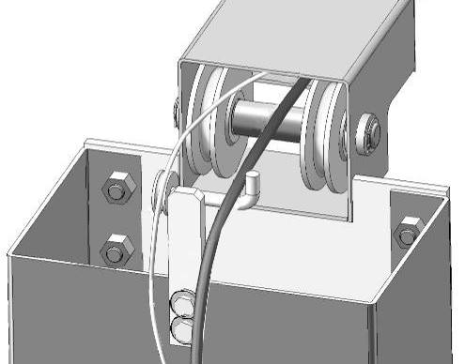
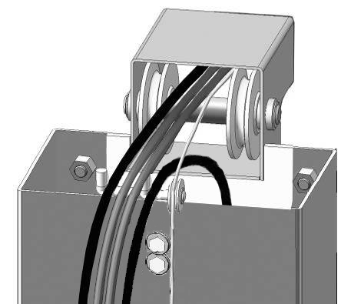
Oil hose
Safety Cable

Wire of cylinder limit switch

Wire of control bar limit switch
Powerside
Fig. 37

Off powerside
Fig. 38

2. Install retainer (See Fig. 39).

65
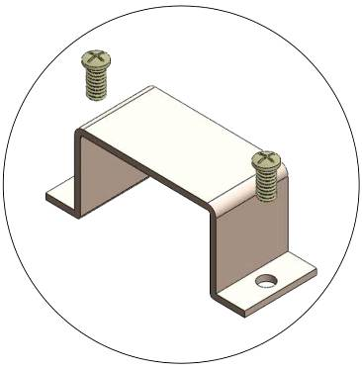
66

Safety Cable
Safety Cable

Oil Hose
Oil Hose
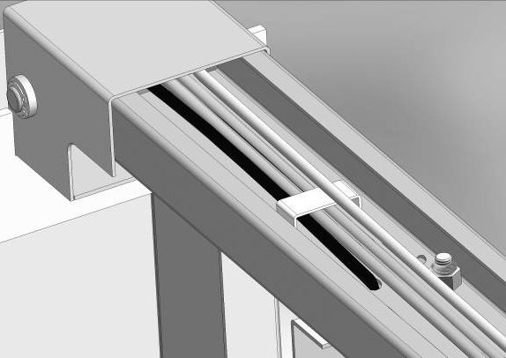
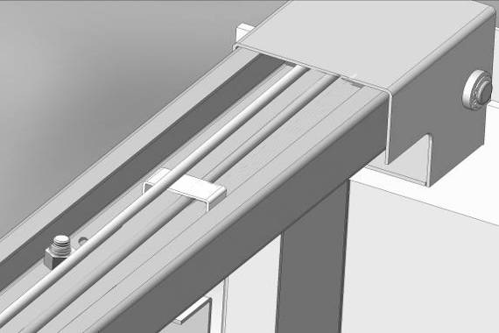

Wire of limit switch
Safety cable can’t not pass through the retainer

Fig. 39

3. Install Protective cover and safety cover.
a. Install protective cover of powerside column (See Fig. 40, 41).
b. The same way to install protective cover of offside column, only offside oil hose inside the protective cover.
c. Install protective cover for high setting (See Fig. 42).
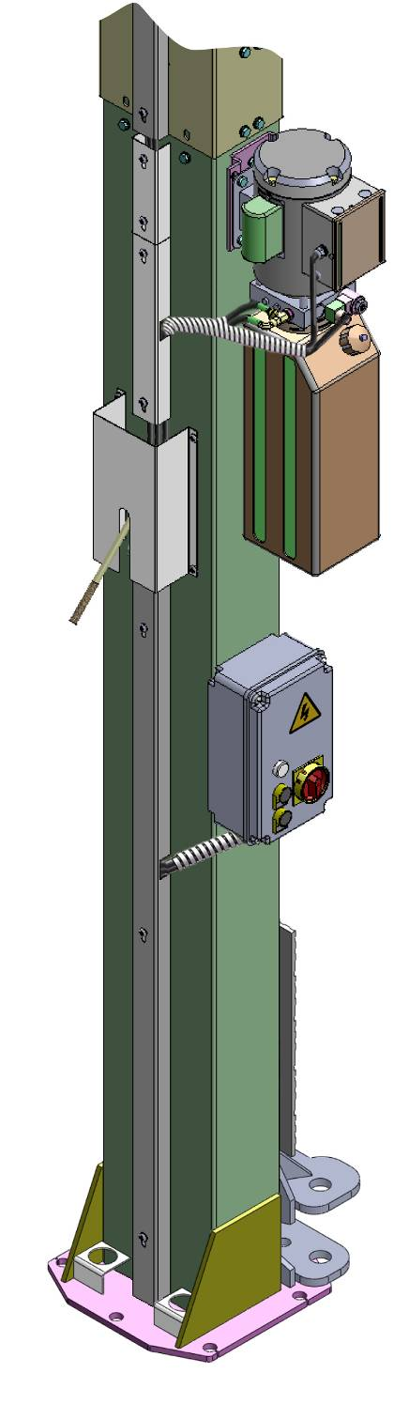
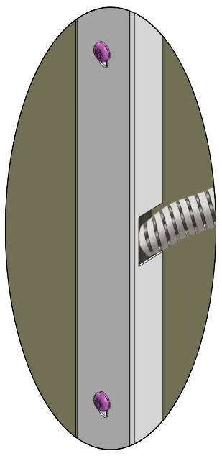
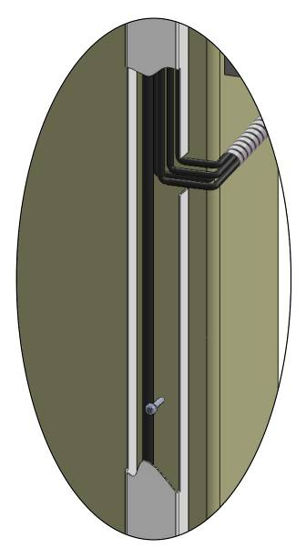
Note: No need to install the shortest protective cover for low setting
Safety Cable

Fig. 40

Fig. 41

Powerside oil hose

No need the shortest Protective cover for low setting

77
18
- Install protective cover and tighten the cup head bolt

- Screw the head cup bolt M6*40

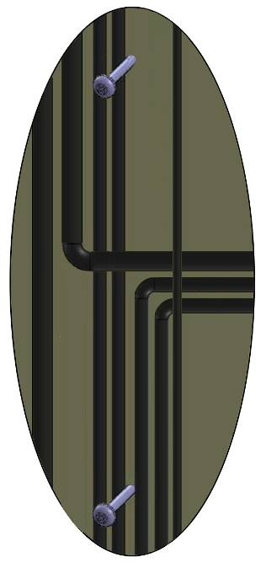
Wire of cylinder limit switch

Power unit oil hose

Wire of hydraulic solenoid valve

Wire of motor

Cylinder oil hose

Wind the white bobbin

Wire of control bar limit switch

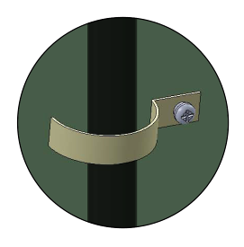

Wind the white bobbin

Fig. 42

P. Install lifting arms and adjust the arm locks.
1. Install the lifting arms (See Fig. 43).
2. Lowing the carriages down to the lowest position, then use the 8# socket head wrench to loosen the socket bolt (See Fig. 44).
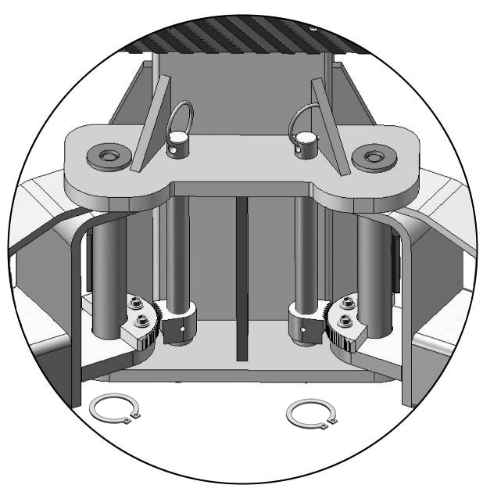
Snap Ring

Fig. 43

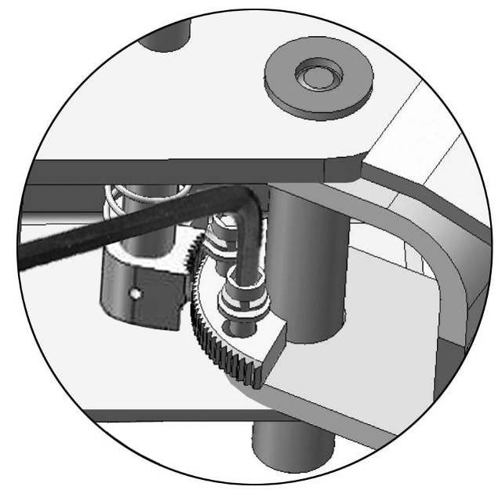
use the 8# socket head wrench to loosen the socket bolt

Fig. 44

3. Adjust the arm lock as direction of arrow (See Fig. 45)
4. Adjust moon gear and arm lock to make it to be meshed, then tighten the socket bolts of arm lock (See Fig.46).

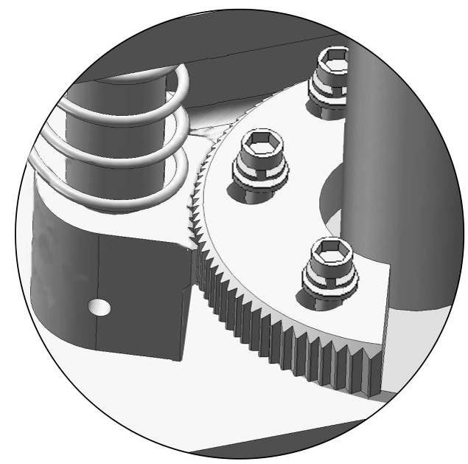
Arm lock

Fig. 45

Locking the bolts after the moon gear and arm lock engaged well

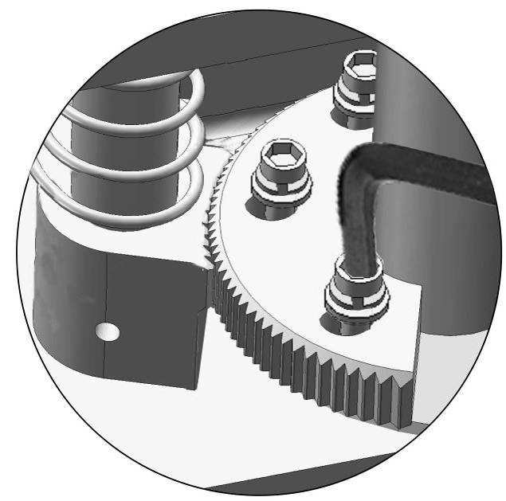

Fig. 46

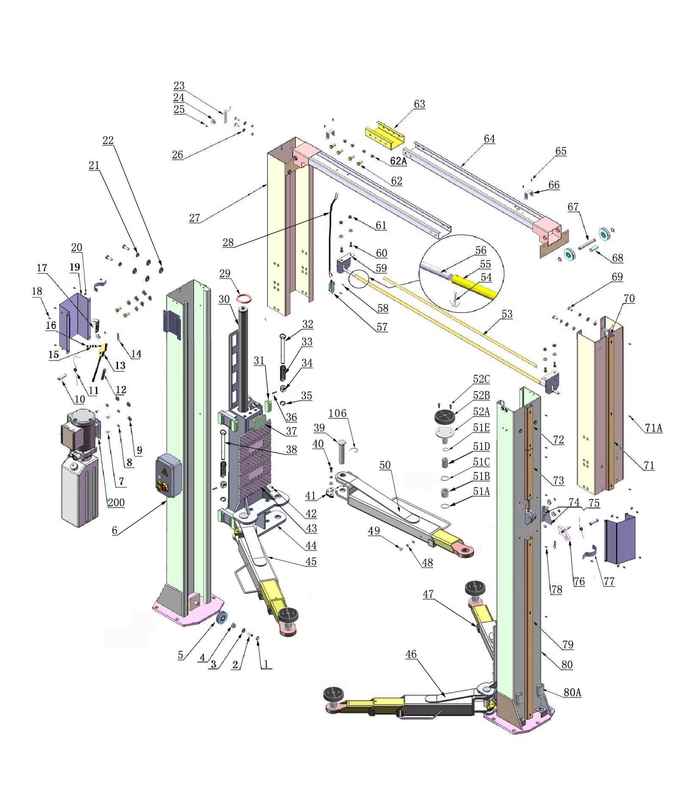
IV. EXPLODED VIEW

Model A204C A240CH

Car in direction

Fig.47

Cylinders
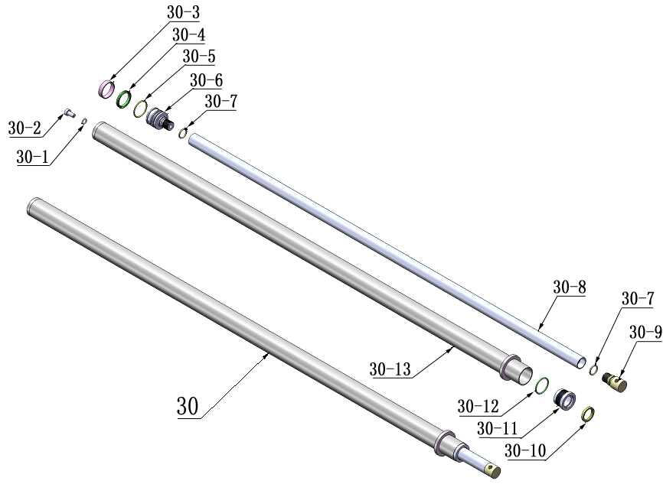

Fig. 48

Control Box
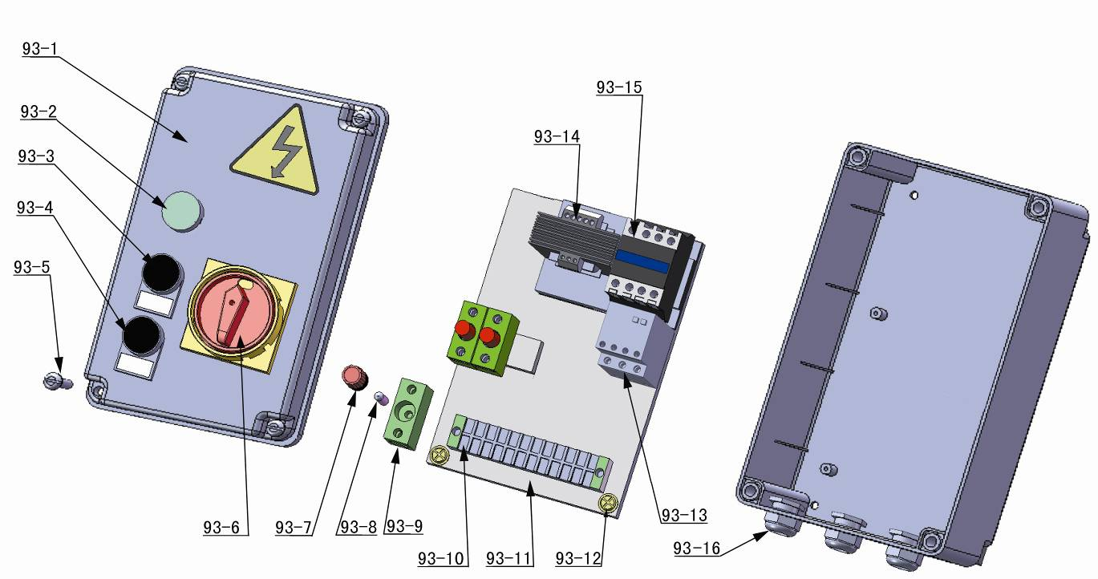

Fig. 49

SPX ELECTRIC POWER UNIT 220V/50HZ/1 phase
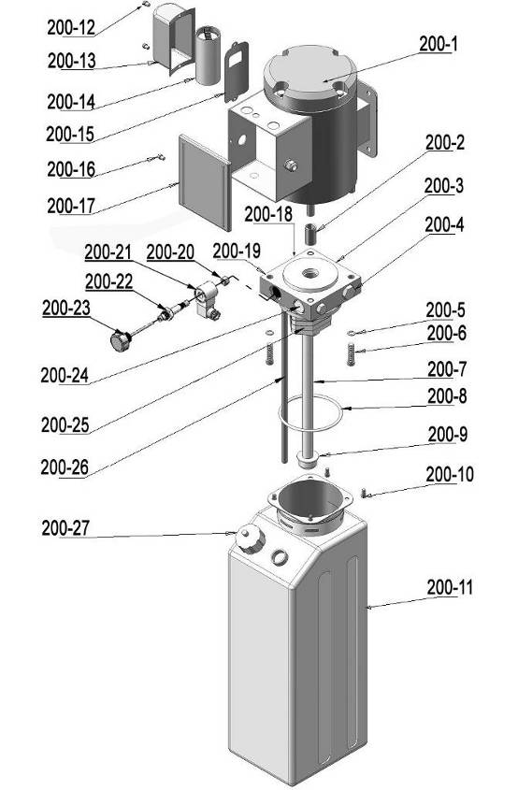

Fig. 50

PEAK ELECTRIC POWER UNIT
220V/50HZ/1 Phase
380V/50HZ/3 Phases
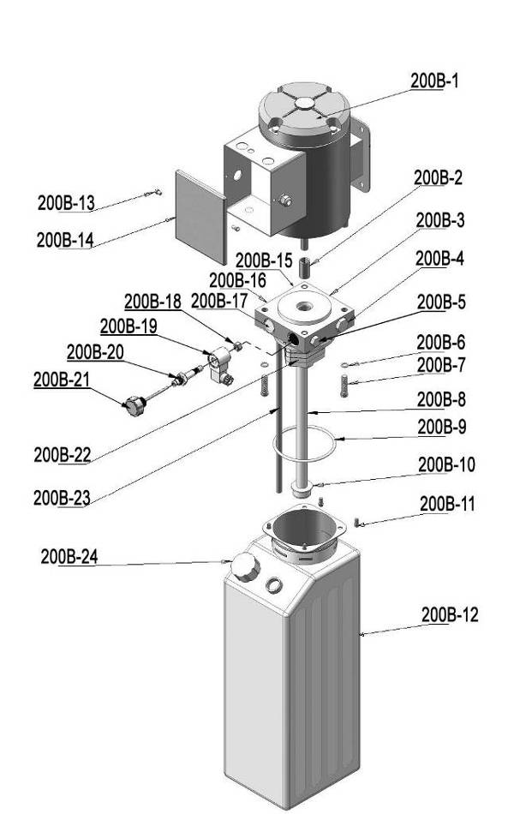
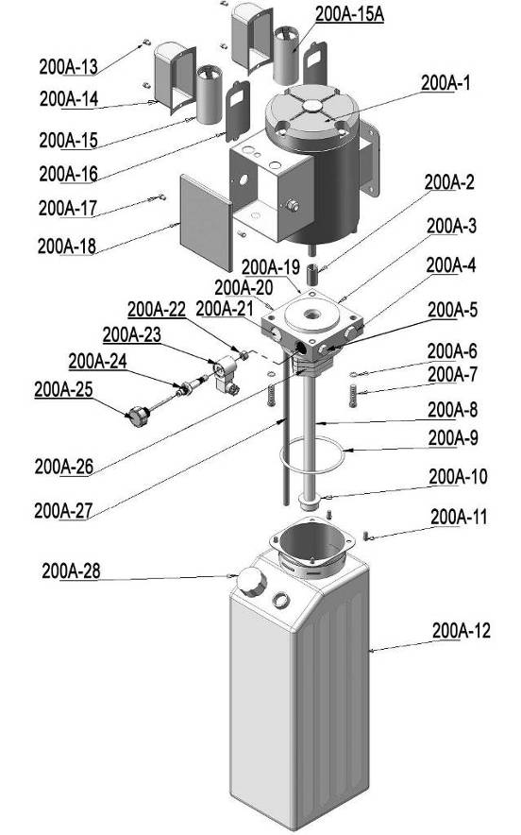

Fig. 51
Illustration of hydraulic valve for SPX & PEAK hydraulic power unit
- SPX Electric power unit, 220V/50HZ, Single phase (See Fig. 52)
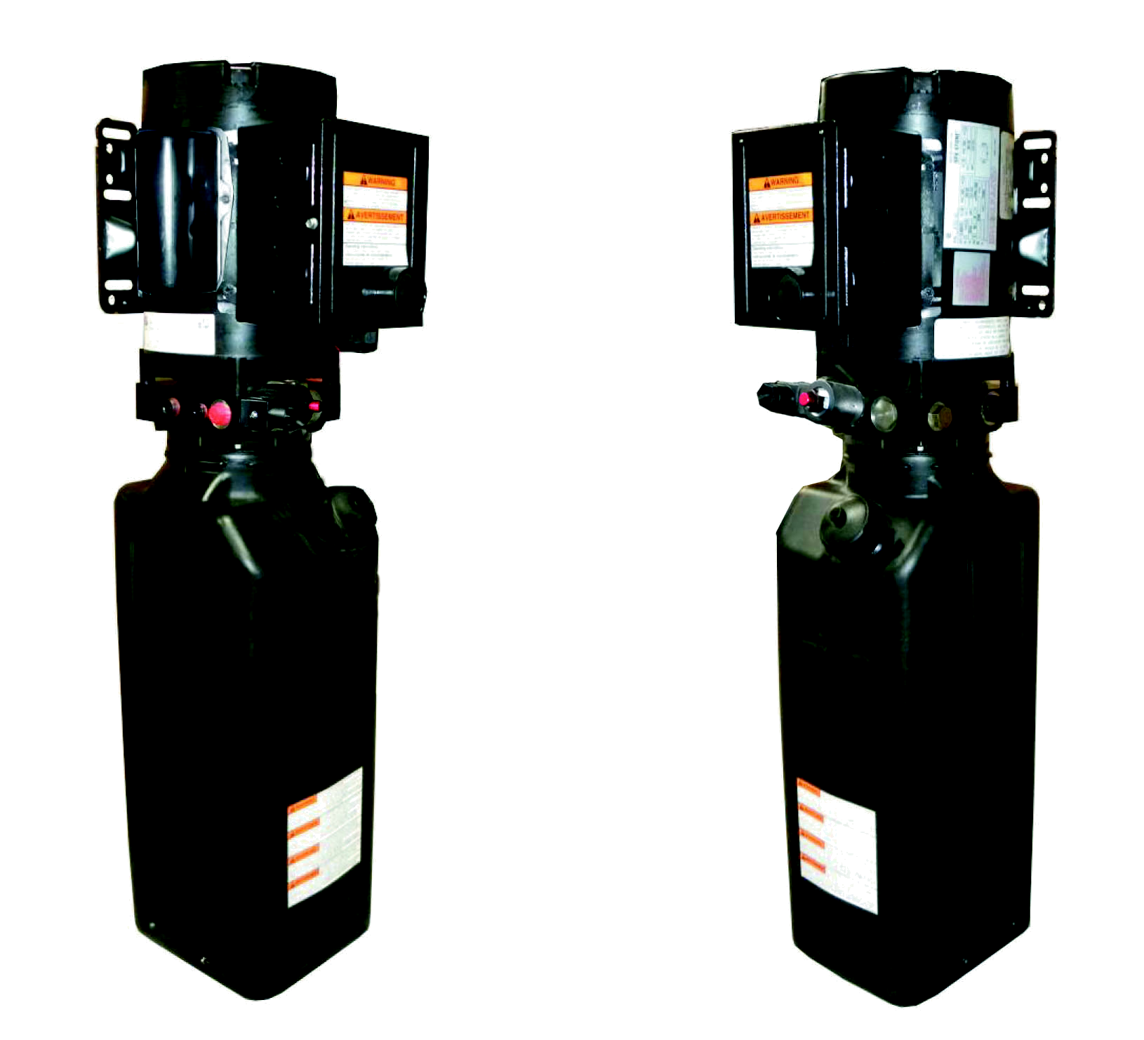
Capacitor
Oil return port
Auxiliary hole
Oil Outlet
Solenoid valve
Check valve
Relief valve
Auxiliary hole

Fig. 52

b. PEAK Electric power unit, 220V/50HZ/ 1 phase (See Fig. 53)

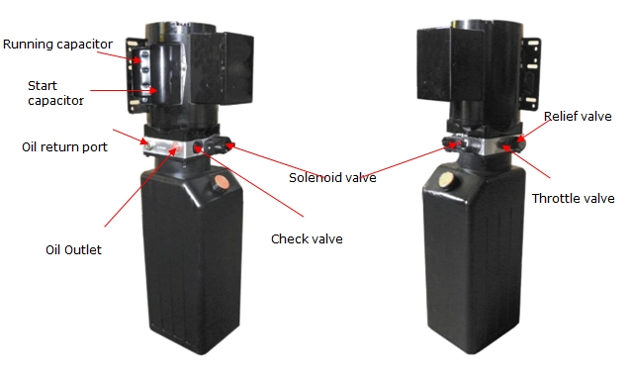

Fig. 53

C. PEAK Electric power unit, 380V/50HZ/3 phases (See Fig. 54)
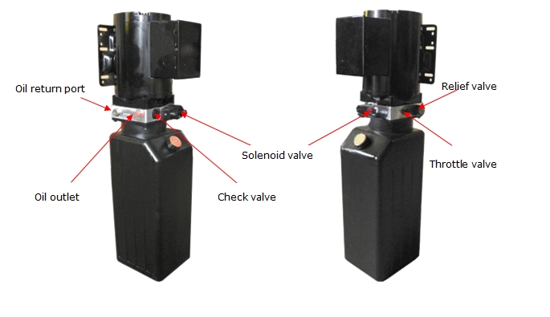

Fig. 54


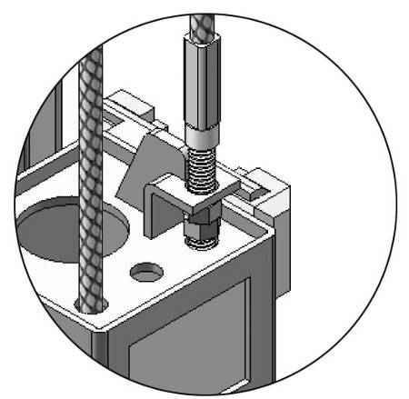
V. TEST RUN
Cable nut
1. Adjust synchronous cable (See Fig. 55)
Use wrench to hold the cable fitting, meanwhile
use ratchet spanner to tighten the cable nut.
Make sure two cables are with the same tension
so that two carriage can work synchronously.
Fit the plastic hole cover on the lifting head.
If the carriage does not Synchronize when lifting,
please tighten the cable nut of lower side carriage.
Fig. 55
2. Adjust safety cable
Lifting the carriage and lock at the same height, strain the Safety Cable and then release a little, and then tighten the cable nuts. Make sure the safety device can always be worked properly. And then install the safety cover.

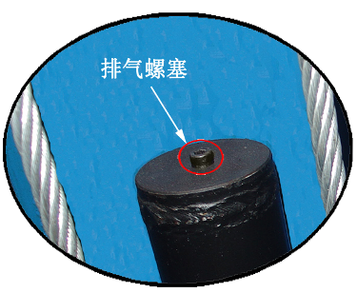
3. Bleeding air
This hydraulic system is designed to bleeding air by loosing
Bleeding plug
the bleeding plug. Lifting the carriages to about 1 meter
height, and loose the bleeding plug, the air would be
bled automatically, then tighten the plug after
bleeding, the lift would work stably and smoothly,
otherwise repeat bleeding (See Fig. 56).
Fig. 56

4. Adjust the lower speed (Only for PEAK power unit)
You can adjust the lower speed of the lift if needing: Loosen the fixing nut of the throttle valve, and then turn the throttle valve clockwise to decrease the lower speed, or counterclockwise to increase the lower speed. Do not forget to tighten the fixing nut after the lower speed adjustment has been done.
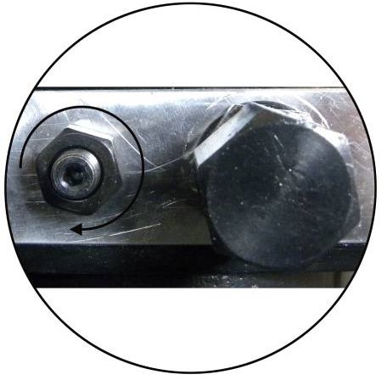
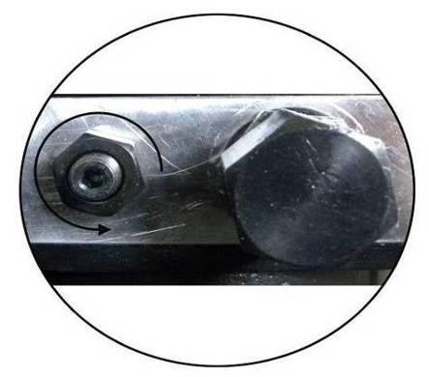
Throttle Valve

Fixing Nut

Counterclockwise to increase the down speed
Clockwise to decrease the down speed

Fig. 57

4. Test with load
After finishing the above adjustment, test running the lift with load. Run the lift in low position for several times first, make sure the lift can rise and lower synchronously, the Safety Device can lock and release synchronously. And then test run the lift to the top completely. If there are anything improper, repeat the above adjustment.
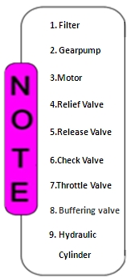
NOTE: It may be vibrated when lifting at start, please lifting it with load for several times, the air would be bled and the vibration would be disappeared automatically.
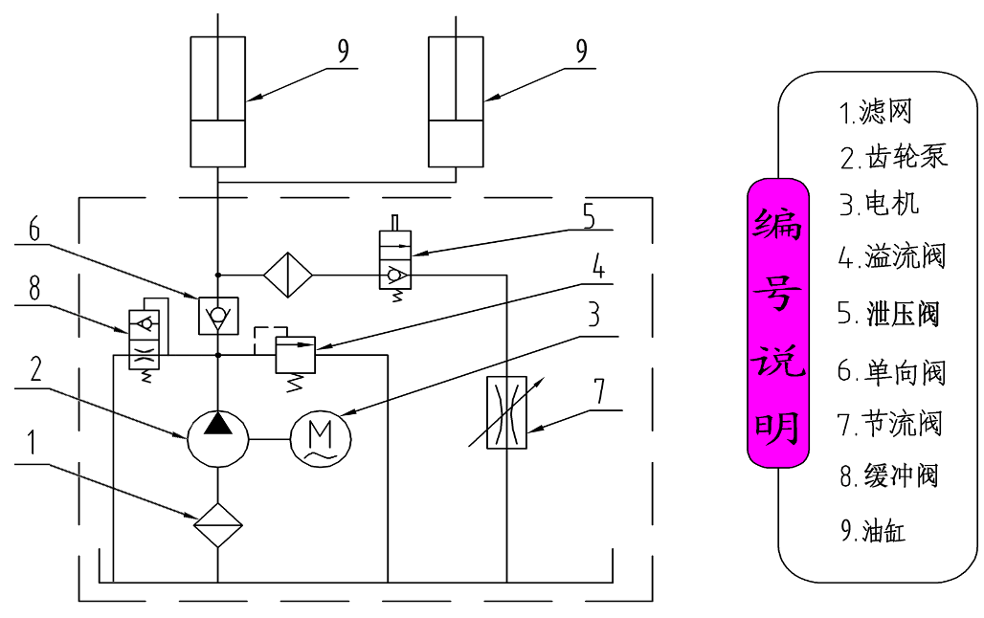

Fig. 58 Hydraulic System

VI. OPERATION INSTRUCTIONS
Please read the safety tips carefully before operating the lift
To lift vehicle
- Keep clean of site near the lift;
- Position lift arms to the lowest position;
- To shortest lift arms;
- Open lift arms;
- Position vehicle between columns;
- Move arms to the vehicle’s lifting point;
Note: The four lift arms must at the same time contact the vehicle’s lifting point where manufacturers recommended
- Turn on the power switch QS1, press the UP button until the lift pads contact underside of vehicle totally. Recheck to make sure vehicle is secure;
- Continue to raise the lift slowly to the desired working height , ensuring the balance of vehicle;
- Press DOWN button, lower lift onto the safety position. The vehicle is ready to repair.

To lower vehicle
- Be sure clear of around and under the lift, only leaving operator in lift area;
- Press the UP button to raise the vehicle slightly, and then release the safety device, press the button DOWN to lower lift.
- Open the arms and position them to the shortest length;
- Drive away the vehicle.
- Turn off the power.

VII.MAINTENANCE SCHEDULE
Monthly:
- Re-torque the anchor bolts to 117 Nm;
- Check all connectors, bolts and pins to insure proper mounting;
- Lubricate cable with lubricant;
- Make a visual inspection of all hydraulic hoses/lines for possible wear or leakage;
- Check safety device and make sure proper condition;
- Lubricate all rollers and pins with 90wt. Gear oil or equivalent;
Note: All anchor bolts should take full torque. If any of the bolts does not function for any reason, DO NOT use the lift until the bolt has been replaced.
Every six months:
- Make a visual inspection of all moving parts for possible wear, interference or damage.
- Check and adjust as necessary, equalizer tension of the cables to insure level lifting.
- Check columns for plumbness.
- Check rubber pads and replace as necessary.
- Check safety device and make sure proper condition.

VIII.TROUBLE SHOOTING
TROUBLE | CAUSE | REMEDY
Motor does not run | 1. Button does not work  2. Wiring connections are not in good condition  3. Motor burned out  4. AC contactor burned out  5. Height limit switch is damaged | 1. Replace button  2. Repair all wiring connections  3. Repair or replace motor  4. Replace AC contactor  5. Replace the limit switch
Motor runs but the lift is not raised | 1. Motor runs in reverse rotation  2. Gear Pump out of operation  3. Release Valve in damage  4. Relief valve or check valve in damage  5. Low oil level | 1.Reverse two power wire  2.Repair or replace  3.Repair or Replace  4.Repair or replace  5.Fill tank
Lift does not stay up | 1. Release valve out of work  2. Relief valve or check valve leakage  3. Cylinder or fittings leaks | Repair or replace
Lift raises slowly | 1. Oil line is jammed  2. Motor running on low voltage  3. Oil mixed with air  4. Gear Pump leaks  5. Overload lifting | 1. Clean the oil line  2. Check electrical system  3. Fill tank  4. Repair or replace  5. Check load
Lift can not lower | 1. Safety device are in activated  2. Release valve in damage  3. Safety cable broken  4. Oil system is jammed  5. Hydraulic solenoid valve out of work | 1. Release the safeties  2. Repair or replace  3. replace  4. Clean the oil system  5. Repair or replace

IX. PARTS LIST FOR A240C and A240CH
Item | Part# | Description | Qty. |  | Note
Item | Part# | Description | A240C | A240CH | Note
(See Fig. 47, Fig.16, 23-29, Fig. 9)
1 | 206019 | Snap Ring | 6 | 6
2 | 206058 | Bolt | 2 | 2
3 | 206059 | Washer | 2 | 2
4 | 209057B | Bronze Bush For Pulley | 6 | 6
5 | 206020 | Pulley | 6 | 6
6 | 206122 | Powerside Column | 1 | 1
200 | 420019 | Electric Power Unit | 1 | 1
7 | 209003 | Hex Bolt | 8 | 8
8 | 209004 | Rubber Ring | 4 | 4
9 | 209005 | Nylok Nut | 8 | 8
10 | 206002 | Safety Pin | 2 | 2
11 | 209007A | Safety Spring | 2 | 2
12 | 206003 | Handle Protective Plastic cushion | 1 | 1
13 | 206004 | Powerside Safety Lock | 1 | 1
14 | 209012 | Hair Pin | 2 | 2
15 | 206006 | Washer | 24 | 24
16 | 206023A | Hex Nut | 2 | 2
17 | 206004A | Safety Pulley Bracket | 1 | 1
18 | 209009 | Cup Head Bolt | 10 | 10
19 | 206081 | Safety Cover | 2 | 2
20 | 420045 | Washer | 16 | 16
20A | 209149 | Lock washer | 6 | 6
21 | 209022 | Washer | 40 | 40
22 | 209021 | Hex nut | 20 | 20
23 | 206010 | Safety Pulley Bracket | 1 | 1
24 | 206009 | Plastic Small Pulley | 5 | 5
25 | 209010 | Snap Ring | 5 | 5
26 | 209033 | Washer | 8 | 8
27 | 206008 | Extension Column | 2 | 0
27 | 206082 | Extension Column | 0 | 2
28 | 206015C | Wire Cable | 1 | 0
28 | 206015D | Wire Cable | 0 | 1
29 | 209111 | Protective Ring For Cylinder | 2 | 2
30 | 217056 | Hydraulic Cylinder | 2 | 2

Item | Part# | Description | Qty. |  | Note
Item | Part# | Description | A240C | A240CH | Note
31 | 206044 | Slider Block | 16 | 16
32 | 206046A | Arm Lock Bar（left） | 4 | 4
33 | 206050A | Spring | 4 | 4
34 | 217044 | Arm Lock | 4 | 4
35 | 206032 | Snap Ring | 4 | 4
36 | 206036 | Hair Pin | 4 | 4
37 | 209016 | Carriage Plastic Cover | 2 | 2
38 | 206046B | Arm Lock Bar（right） | 2 | 2
39 | 206136 | Arm Pin | 4 | 4
40 | 206048 | Socket Bolt | 12 | 12
41 | 206049 | Moon Gear | 4 | 4
42 | 209019 | Screw | 12 | 12
43 | 209018 | Protective Rubber | 2 | 2
44 | 206111 | Carriage | 2 | 2
45 | 206053 | Lifting Arm – Front Right | 1 | 1
45A | 206087A | Outer Arm - Front Right | 1 | 1
45B | 206088 | Middle Arm - Front Right | 1 | 1
45C | 206095 | Inner Arm - Front Right | 1 | 1
46 | 206055 | Lifting Arm - Front Left | 1 | 1
46A | 206092A | Outer Arm - Front Left | 1 | 1
46B | 206093 | Middle Arm - Front Left | 1 | 1
46C | 206095 | Inner Arm - Front Left | 1 | 1
47 | 206039 | Lifting Arm – Rear Left | 1 | 1
47A | 206094A | Outer Arm - Rear Left | 1 | 1
47B | 206096 | Inner Arm - Rear Left | 1 | 1
48 | 209039 | Lock washer | 40 | 40
49 | 209038 | Hex bolt | 6 | 6
50 | 206037 | Lifting Arm - Rear Right | 1 | 1
50A | 206090A | Outer Arm - Rear Right | 1 | 1
50B | 206096 | Inner Arm - Rear Right | 1 | 1
51 | 203054 | Rubber Pad Assy. | 4 | 4
51A | 201060 | O Ring | 8 | 8
51B | 203024 | Adjustment Adapter | 4 | 4
51C | 203042 | Lock washer | 8 | 8
51D | 203025 | Adjustment Screw | 4 | 4
51E | 203041 | Lock washer | 4 | 4
52A | 203026 | Rubber Pad Frame | 4 | 4
Item | Part# | Description | Qty. |  | Note
Item | Part# | Description | A240C | A240CH
52B | 203043 | Rubber pad for Combined Adapter | 4 | 4
52C | 420043 | Socket bolt | 8 | 8
53 | 206025A | Foam Cushion | 1 | 1
54 | 201005 | Split Pin | 2 | 2
55 | 206129 | Control Bar | 1 | 1
56 | 206025C | Connecting Pin for Control Bar | 2 | 2
57 | 206013 | Limit Switch | 2 | 2
58 | 206011 | Cup Head Bolt | 2 | 2
59 | 206042 | Control Bar Support Bracket | 2 | 2
60 | 206041 | Hex Bolt | 4 | 4
61 | 206023 | Nylok Nut | 12 | 12
62 | 206017 | Hex Bolt | 28 | 28
62A | 209056 | Nylok nut | 10 | 10
63 | 206016 | Connecting Bracket | 1 | 1
64 | 206018A | Top Beam W/Bracket | 2 | 2
65 | 206028 | Cup Head Bolt | 4 | 4
66 | 206029 | Retainer | 2 | 2
67 | 206021 | Pin For Pulley | 2 | 2
68 | 206022 | Pin Spacer | 2 | 2
69 | 206024 | Hex Bolt | 8 | 8
70 | 206010A | Safety Pulley Bracket | 1 | 1
71A | 206110 | Cup Head Bolt | 6 | 6
71 | 206085 | Protective cover | 2 | 2
72 | 206084 | Protective cover | 2 | 2
73 | 206083 | Protective cover | 2 | 2
74 | 640050 | Socket bolt | 4 | 4
75 | 206008C | Safety Pulley Bracket | 1 | 1
76 | 206026 | Offside Safety Lock | 1 | 1
77 | 217048 | Retainer | 2 | 2
78 | 206079 | Cup Head Bolt | 20 | 20
79 | 206080 | Protective cover | 2 | 2
80 | 206030B | Offside column | 1 | 1
80A | 203034 | Adapter 3” | 4 | 4
81 | 209059 | Anchor Bolt | 10 | 10
82 | 620065 | Shim | 10 | 10
83 | 209066 | Cable Nut | 8 | 8
Item | Part# | Description | Qty. |  | Note
Item | Part# | Description | A240C | A240CH | Note
84 | 206064A | Cable | 2 | 0
84 | 206064B | Cable | 0 | 2
85 | 206065 | Safety Cable | 1 | 0
85 | 206065A | Safety Cable | 0 | 1
86 | 203032 | Motor Bracket | 1 | 1
87 | 206134 | Oil Hose | 1 | 0
 | 206135 | Oil Hose | 0 | 1
88 | 209060 | 90 Fitting For Power Unit | 1 | 1
88A | 211016 | T- Fitting | 1 | 1
89 | 209064 | Straight Fitting | 2 | 2
90 | 206062 | Straight Fitting | 2 | 2
91 | 233009 | Pipe Fitting | 2 | 2
92 | 206130 | Oil Hose | 2 | 0
92 | 206131 | Oil Hose | 0 | 2
93 | 206123 | Control Box | 1 | 1
94 | 209145 | Cup Head Bolt | 2 | 2
95 | 206120 | Wire cable | 1 | 0
95 | 206121 | Wire cable | 0 | 1
96 | 620095 | Hex Nut | 4 | 4
97 | 620109 | Cup head bolt | 2 | 2
98 | 420164 | Cup head bolt | 2 | 2
99 | 209126 | Hex Nut | 2 | 2
100 | 420168A | White bobbin | 1 | 1
101 | 206116 | Wire for Hydraulic Solenoid Valve | 1 | 1
102 | 206139 | Motor Wire | 1 | 1
103 | 206114 | Protecting plastic hose | 1 | 0
103 | 206115 | Protecting plastic hose | 0 | 1
104 | 209152 | Ties | 3 | 3
105 | 217145 | Plastic clamp | 3 | 3
106 | 520023 | Snap Ring | 4 | 4
107 | 206502B | Parts Box | 1 | 0
107 | 206503B | Parts Box | 0 | 1
Parts For Hydraulic Cylinder (See Fig.48)
30-1 | 209069 | O-Ring | 2 | 2
30-2 | 209070 | Bleeding Plug | 2 | 2
30-3 | 209071 | Support Ring | 2 | 2
Item | Part# | Description | Qty. |  | Note
Item | Part# | Description | A240C | A240CH
30-4 | 209072 | Y-Ring | 2 | 2
30-5 | 209073 | O-Ring | 2 | 2
30-6 | 209074 | Piston | 2 | 2
30-7 | 209075 | O-Ring | 2 | 2
30-8 | 217076 | Piston Rod | 2 | 2
30-9 | 209077 | Piston Rod Fitting | 2 | 2
30-10 | 209078 | Dust Ring | 2 | 2
30-11 | 209079 | Head Cap | 2 | 2
30-12 | 209080 | O-Ring | 2 | 2
30-13 | 209081A | Bore Weldment | 2 | 2
Part for Control Box (See Fig.49)
93-1 | 420069A | Cover Of Control Box | 1 | 1
93-2 | 61K077 | Alarm Lamp | 1 | 1
93-3 | 420071 | Button UP | 1 | 1
93-4 | 420072 | Button DOWN | 1 | 1
93-5 | 420139 | Screw | 4 | 4
93-6 | 420074 | Power Switch (QSI) | 1 | 1
93-7 | 420085 | Fuse Cap | 3 | 3
93-8 | 420086 | Fuse (FU1) | 3 | 3
93-9 | 420087 | Fuse Base | 3 | 3
93-10 | 620082 | 15 digits Terminal Group | 1 | 1
93-11 | 420133A | Panel for Installing Element | 1 | 1
93-12 | 420073 | Cup Head Bolt | 4 | 4
93-13 | 420140 | Thermal Relay (FR) | 1 | 1
93-14 | 420134 | Transformer (TC) | 1 | 1
93-15 | 420084A | 24V AC Contactor (KM) | 1 | 1
93-16 | 420088 | Fitting For White Wire Cable | 3 | 3
Parts For SPX Electric Power Unit 220V/50HZ/1 Phase (See Fig.50)
200-1 | 209082 | Motor | 1 | 1
200-2 | 209083 | Motor Connecting Shaft | 1 | 1
200-3 | 209084 | Valve Body | 1 | 1
200-4 | 209085 | Relief Valve | 1 | 1
200-5 | 209086 | Lock Washer | 4 | 4
200-6 | 209087 | Socket Bolt | 4 | 4
200-7 | 209088 | Inlet Pipe | 1 | 1
200-8 | 209089 | O-ring | 1 | 1
Item | Part# | Description | Qty. |  | Note
Item | Part# | Description | A240C | A240CH | Note
200-9 | 209090 | Filter | 1 | 1
200-10 | 209091 | Hex Bolt | 4 | 4
200-11 | 209092 | Reservoir | 1 | 1
200-12 | 209093 | Cup Head Bolt | 2 | 2
200-13 | 209094 | Cover for Capacitor | 1 | 1
200-14 | 209095 | Capacitor | 1 | 1
200-15 | 209096 | Rubber Gasket | 1 | 1
200-16 | 209097 | Hex Bolt | 1 | 1
200-17 | 209098 | Cover of Motor Terminal Box | 1 | 1
200-18 | 209110 | Oil Return Port | 1 | 1
200-19 | 209100 | Oil Outlet | 1 | 1
200-20 | 209162 | Hydraulic Solenoid Valve Nut | 1 | 1
200-21 | 209115 | Hydraulic Solenoid Valve Coil | 1 | 1
200-22 | 209116 | Hydraulic Solenoid Valve Body | 1 | 1
200-23 | 209117 | Pressure Adjusting Bar | 1 | 1
200-24 | 420070 | Check Valve | 1 | 1
200-25 | 209106 | Gear Pump | 1 | 1
200-26 | 209107 | Oil Return Pipe | 1 | 1
200-27 | 209108 | Filler Cap | 1 | 1
Parts For PEAK Electric Power Unit 220V/50HZ/1 Phase (See Fig.51)
200A-1 | 209082A | Motor | 1 | 1
200A-2 | 209083A | Motor Connecting Shaft | 1 | 1
200A-3 | 209084A | Valve Body | 1 | 1
200A-4 | 209085A | Relief Valve | 1 | 1
200A-5 | 209113 | Throttle Valve | 1 | 1
200A-6 | 209086A | Lock Washer | 4 | 4
200A-7 | 209087A | Socket Bolt | 4 | 4
200A-8 | 209088A | Inlet Pipe | 1 | 1
200A-9 | 209089A | O-ring | 1 | 1
200A-10 | 209090A | Filter | 1 | 1
200A-11 | 209091A | Hex Bolt | 4 | 4
200A-12 | 209092A | Reservoir | 1 | 1
200A-13 | 209093A | Cup Head Bolt | 4 | 4
200A-14 | 209094A | Cover for Capacitor | 2 | 2
200A-15 | 209095A | Start Capacitor | 1 | 1
200A-15A | 209095B | Run Capacitor | 1 | 1
Item | Part# | Description | Qty. |  | Note
Item | Part# | Description | A240C | A240CH | Note
200A-16 | 209096A | Rubber Gasket | 2 | 2
200A-17 | 209097A | Hex Bolt | 2 | 2
200A-18 | 209098A | Cover of Motor Terminal Box | 1 | 1
200A-19 | 209110A | Oil Return Port | 1 | 1
200A-20 | 209100A | Oil Outlet | 1 | 1
200A-21 | 420070A | Check Valve | 1 | 1
200A-22 | 209162A | Hydraulic Solenoid Valve Nut | 1 | 1
200A-23 | 209115A | Hydraulic Solenoid Valve Coil | 1 | 1
200A-24 | 209116A | Hydraulic Solenoid Valve Body | 1 | 1
200A-25 | 209117A | Pressure Adjusting Bar | 1 | 1
200A-26 | 209106A | Gear Pump | 1 | 1
200A-27 | 209107A | Oil Return Pipe | 1 | 1
200A-28 | 209108A | Filler Cap | 1 | 1
Parts For PEAK Electric Power Unit 380V/50HZ/3 Phase ( See Fig.51)
200B-1 | 209118 | Motor | 1 | 1
200B-2 | 209083A | Motor Connecting Shaft | 1 | 1
200B-3 | 209084A | Valve Body | 1 | 1
200B-4 | 209085A | Relief Valve | 1 | 1
200B-5 | 209113 | Throttle Valve | 1 | 1
200B-6 | 209086A | Lock Washer | 4 | 4
200B-7 | 209087A | Socket Bolt | 4 | 4
200B-8 | 209088A | Inlet Pipe | 1 | 1
200B-9 | 209089A | O-ring | 1 | 1
200B-10 | 209090A | Filter | 1 | 1
200B-11 | 209091A | Hex Bolt | 4 | 4
200B-12 | 209092A | Reservoir | 1 | 1
200B-13 | 209097A | Hex Bolt | 2 | 2
200B-14 | 209098A | Cover of Motor Terminal Box | 1 | 1
200B-15 | 209110A | Oil Return Port | 1 | 1
200B-16 | 209100A | Oil Outlet | 1 | 1
200B-17 | 420070A | Check Valve | 1 | 1
200B-18 | 209162A | Hydraulic Solenoid Valve Nut | 1 | 1
200B-19 | 209115A | Hydraulic Solenoid Valve Coil | 1 | 1
200B-20 | 209116A | Hydraulic Solenoid Valve Body | 1 | 1
200B-21 | 209117A | Pressure Adjusting Bar | 1 | 1
200B-22 | 209106A | Gear Pump | 1 | 1
200B-23 | 209107A | Oil Return Pipe | 1 | 1
200B-24 | 209108A | Filler Cap | 1 | 1

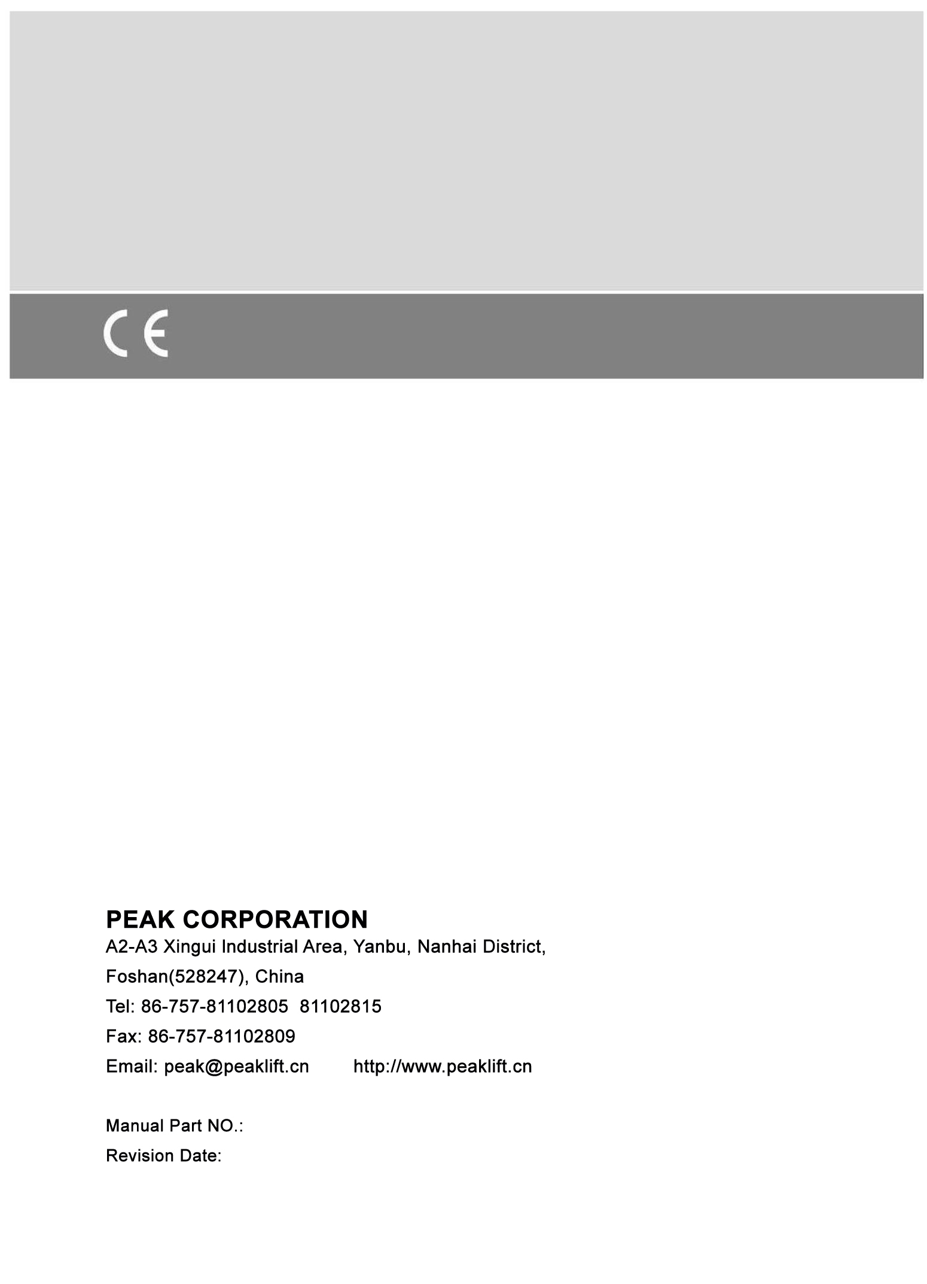
72225402
01/2014

